KING COUNTY
WATER DISTRICT NO. 20
12606 First Avenue South
Burien, Washington 98168
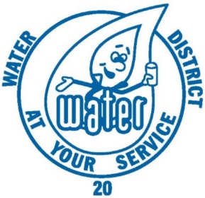

Developer Extension
Agreement Manual

KING COUNTY

WATER DISTRICT NO. 20

Water District Office
12606 First Avenue South
Burien, Washington 98168
Telephone: (206) 243-3990
Fax: (206) 244-7514

District Commissioners
Gary G. Coy
Russ Pritchard
Darold P. Doell

General Manager
Michael Martin

Office Manager
Lisa Gee

Field Superintendent
Chris Cordi

Engineer
PACE Engineers, Inc.
11255 Kirkland Way, Suite 300
Kirkland, WA 98033
Telephone: (425) 827-2014
Fax: (425) 827-5043

Attorney
Douglas H. Moreland, Attorney at Law
417 S.W. 152nd Street
Burien, WA 98166
Telephone: (206) 242-4900

Adopted by Resolution No. 774
Dated: 9/18/2019
Revised: 12/29/2021
FOREWORD

This Developer Extension Manual is intended to inform and aid developers, agencies and other interested parties regarding the requirements and policies of Water District No. 20 as it relates to additions or extensions to the water system within the Water District No. 20 service area.

Included in this Developer Extension Manual are an application form for an extension to the system or secondary water facilities, the District’s standard Developer Extension Agreement and related forms, and the District’s material specifications and standard details relating to Extension projects.

If you have any questions, please feel free to call Michael Martin, General Manager, at (206) 243-3990.

Michael Martin
General Manager
Water District No. 20
King County, Washington

CONTENTS

Developer Extension Application Summary (Attach To Application) 1
Application for Developer Extension Project 3
Developer Extension Project Checklist 7
Developer Extension Agreement – Water System Improvements 11
1. Location of Extension 12
2. Description of Improvements and Ownership 12
3. Fees and Charges 13
4. Design and Construction 14
5. Reimbursement Application 14
6. Final Acceptance – Conditions Precedent 14
7. Responsibility for Project Management 15
8. Limitation of Period for Acceptance 15
9. Governing Law/Forum 15
10. No Third Party Shall Have Any Right Hereunder 15
11. Documents Required Prior to Provision of Water Service 16
12. Remedies Available to District – Unpaid Accounts to Become Liens Against Property 16
13. Insurance 17
14. Indemnification 17
15. Agreement 17
Summary of Costs 19
Regulations: Extensions to the Water System 21
1.1 Policy 21
1.2 Application for Extension 21
1.3 Approval of Application 21
1.4 Preparation of Plans and Standards of Work 22
1.5 Backflow Prevention 22
1.6 Fire Sprinklers/Irrigation System Connection 23
1.7 District Services During Construction 24
1.8 Relation Between the Applicant and District...... 24
1.9 Submittals of Plans to Other Agencies............ 24
2.0 Public Liability and Property Damage Insurance... 24
2.1 Developer's Performance and Maintenance Bonds..................... 25
2.2 Easements and Bill of Sale....................... 26
2.3 Reimbursement Agreement Execution and Recording 27
2.4 Notification and Prosecution of Work 28
2.5 Developer Responsible for Work 29
2.6 Water Service 30
2.7 Certificate of Cost 30
2.8 Hold Harmless and Indemnification Agreement 30
2.9 Bill of Sale and Two Year Warranty 31

Standards for Water Supply 33
Design Standards
A. Domestic Demand – Peak Instant Flow 33
B. Fire Flow Demand 33
C. Design Criteria: Flows – Pressure 34
D. Pressure Reducing Valves – Domestic Service 34
E. Design Flow Analysis 34
Physical Facility Standards
A. Looping 35
B. Extending the Main 35
C. Minimum Main Size 35
D. Fire Protection 36
E. System Valving 37
F. Pressure Reducing Valves – Domestic 37
G. Reduced Pressure Backflow Assembly 38
Standards for Street Lighting 39
A. History 39
B. Existing Street Light Facilities and Services 39
C. Street Lighting System Services 39
District Standard Forms
Developer's Performance Bond 43
Insurance Requirements for Developer Extension Agreements 45
Insurance Coverage Questionnaire 51
Endorsements 53
Bill of Sale of Water Facilities (Individual or Partnership) 59
Bill of Sale of Water Facilities (Corporation or LLC Entity) 63
Easement for Water Lines 67
Real Property License 73
Application for Reimbursement Agreement for Water Facilities 75
Reimbursement Agreement 77
Certification of Cost Forms
Water Main Facility 87
Developer's Certificate of Cost (Simplified) Water Main Facility 89
Developer's Certificate of Cost (Simplified) Secondary Water Facilities 91
General Engineering Specifications GE-1 to GE-20
Standard Details W-01 to W-28

KING COUNTY WATER DISTRICT NO. 20

Developer Extension Application Summary
(Attach to Application)
PROJECT INFORMATION

Name of Development
If subdivision or short plat, number of lots
Meter size required

Date Deposit Paid
Date Agreement Signed

DEVELOPER CONTRACTOR

Name Name

Property owner (if not the Developer)

Address Address

Telephone Telephone
Cell Cell
Email Email

Designate Developer Status Contractor Registration #
_____Corporation
_____Partnership
_____Limited Liability Company Developer Engineer
_____Sole Proprietorship
_____Attach Copy Current Business License Name
*Attach documentation to verify status

Assigned District Engineer Address
Telephone
Cell
Email
Contact Person

This page is intentionally left blank.

WATER DISTRICT NO. 20
KING COUNTY, WASHINGTON

APPLICATION FOR DEVELOPER EXTENSION PROJECT
1. The undersigned hereby makes application to Water District No. 20 (“District”), King County, Washington, to construct and install a:

Mainline Extension with Secondary Facilities

or
Secondary Facilities (New fire hydrant, detector check valve,
or sprinkler or irrigation system)

in the public right-of-way under the District's franchise, right-of-way permits, and/or on easements which are subject to the approval of the District and to connect to the District's water system.

2. Provide the following contact information for Applicant:

Authorized Representative(s):
Mailing Address:
Telephone No.:
Email Address:
Application Page 1 of 4

3. The proposed extension will be installed in roads and/or on other approved right-of-ways or easements and shall be for the use and benefit of the real property described below:

Tax Parcel No.:

Common Street Address:

Legal Description:

The above described property is referred to herein as the “Property”.

By its signature on this Application, the Applicant represents and warrants that it is the legal owner of the Property.

4. Describe the type of improvement planned for the Property:
Single family dwelling, duplex, apartment house complex, industrial or commercial use, and the proposed number of units:

Other:

5. Identify the anticipated fire flow requirements for the contemplated improvement. Requirements to be determined by the Fire Authority having Jurisdiction.
Fire Flow Anticipated/Required:

6. Identify the anticipated start date for construction of the project and the anticipated completion date of the project:
Start Construction:
Complete Construction:

Application Page 2 of 4
7. Return this Application to the District along with a check in the amount of $150.00 which is a non-refundable administrative fee relating to the District’s review and processing of the Application.

8. Have you made an application to King County or city (i.e., Burien, SeaTac or Tukwila) with land use jurisdiction over the Property for a building permit, plat approval, a short plat, or a planned unit development? If so, has the land use agency given its approval to your plan? Has your plat, short plat or planned unit development been prepared, reviewed and/or approved by a licensed surveyor? Attach relevant documents.
Name of county or city with land use jurisdiction:
Responses to questions asked above:

9. Attached to this Application is a Developer Extension Project checklist. Please advise if there are any items on the checklist you do not understand, have questions about, or you may not be able to comply with.

10. Do you want the District Engineer to prepare the plan for the proposed project?

Yes No

a. If yes, the engineering plan design deposit charged by the District will be determined by the District’s Engineer and shall be paid within ten (10) days after the execution of the Developer Extension Agreement (“Agreement”). Upon final approval of the plans by the District, the remainder of the engineering fee shall be paid. The final fee will depend on the complexity of the project and will be based on actual time and material costs incurred.

It is assumed that the Developer will perform all surveying work and provide a required base sheet. Any surveying work or base sheet development performed on the part of the District or by its Engineer will be considered additional work and therefore will be chargeable to the Developer in addition to the fees described above.

b. If no, and you decide to have your own engineer prepare the plan, the District's deposit amount for engineering plan review and approval of the proposed plan for a water main extension or secondary water facilities will be $2,500.00 paid at the time of execution of the Agreement. This deposit shall be paid prior to review of the plans by the District Engineer. The Applicant's engineer shall provide plans in accordance with the District's standards and format, which are available from the District Engineer. Upon final approval of the plans by the District, the remainder of the engineering fee shall be paid. The final fee will depend on complexity of the project and will be based on actual time and material costs incurred.
Application Page 3 of 4

11. Have you or one of your agents completed an environmental checklist to determine whether or not the project will require an environmental impact statement?

Yes No

If yes, please supply a copy of the environmental checklist or describe what action has been taken regarding environmental evaluations.

12. A deposit of $1,000.00 shall be collected by the District prior to start of construction and will be applied to charges for services described in Section 1.8 of the Regulations, Extensions to the Water System attached to the Agreement.

13. The District will prepare or review the easement for water lines and bill of sale at Applicant's expense. Charges for easement preparation or review will be based on the actual time and expense incurred by the District Engineer or District legal counsel in the preparation or review of such documents, in addition to the other fees described in the Application or Agreement. An initial deposit of $1,500 to cover the District’s document preparation or review fees will be collected by the District. Amounts incurred above the deposit amount will need to be paid by the Applicant.

14. The following documents shall be attached to and submitted with the Application: (a) a preliminary plan setting forth the proposed development, (b) a copy of Applicant’s business license, (c) documents showing the form and/or status of the business entity utilized by the Applicant (e.g., corporation, limited liability company, partnership), and (d) document evidencing Applicant’s ownership of the Property.

Application prepared by:

Date:

Applicant:

Address:

Engineer:

Address:

Architect:

Address:
Application Page 4 of 4

WATER DISTRICT NO. 20
KING COUNTY, WASHINGTON

DEVELOPER EXTENSION PROJECT CHECKLIST
A. Preliminary Application Finished Date

1. Application completed and submitted to District. – (Developer)

- Administrative fee paid. – (Developer)
[$150.00 non-refundable – All deposits shall be Cash, Check,
or Money Order made out to “King County Water District No. 20”]

- Verification of business license, corporate/LLC status and ___________
Property ownership. – (District)

- Application reviewed by General Manager. After preliminary review, if the DE is viable, the General Manager will present to the Board for authorization – (District) ___________

- Applicant notified of decision on Application. After Board Approval, Applicant will be notifed via mail, email, or by telephone. – (District) ___________

- Preliminary site plan setting forth the proposed development. Provide a one-half size set and PDF for preliminary review. ___________

  - Developer Extension Agreement Finished Date

- Developer Extension Agreement signed. – (Developer) ___________

- Developer Extension Agreement signed. – (Developer)

        - Plan review deposit. [$2,500.00] ___________

or
        - Plan design deposit. (To be determined by District’s ___________
Engineer depending on project complexity)

- Documents deposit. [$1,500.00] – (Developer) ___________
DE Project Checklist Page 1 of 3
- Applicant deposit for District services. [$1,000.00] - ___________
- (Developer)

- Calculation of deposit amounts due with Developer
Extension Agreement. – (District) ___________

TOTAL Deposits Due For Plan Review $__________

C. Design and Administration Finished Date

1. Water plan prepared by Engineer and submitted to District
for review. Water system plan will be reviewed, redlined,
and then returned to Developer with an itemized comment letter. – (Developer) ___________

2. Approved King County Fire Marshal plan
provided to District. – (Developer)

3. Remaining balance of engineering fees paid. – (Developer)

4. Capital Facilities Charges paid in full. – (Developer)

5. Applicable permits obtained. – (District) ___________

TOTAL Deposits Due For General Facilities Charges $___________

6. Plan approved and signed by General Manager. Provide a PDF and 2 full size plans sets for signature. – (District)

D. Pre-Construction Phase Finished Date

1. Certificate of Insurance, and questionnaire filled out by Insurance Agent /Representative and provided to District.
- (Developer)

2. Performance Bond provided for 100% of actual project cost. Estimated prcost may be used if actual cost is unknown. – (Developer)

3. Attend preconstruction conference. – (District & Developer)

E. Construction Phase Finished Date
DE Project Checklist Page 2 of 3
- Start of construction authorized. – (District)

- Project inspected and tests completed. – (District)

- Construction completed. – (Developer)

- Application for Reimbursement Agreement submitted.
(If applicable) – (Developer)

- Contractor Redlines submitted to District. – (Developer)

- Project CAD files provided to District. – (Developer)

F. Requirements Before Service is Provided Finished Date
and Main Accepted for Service

1. Approval of construction. – (District)

2. Final approved construction record drawings. – (District) ___________

3. Executed Bill of Sale delivered to District. – (Developer)

4. Easements executed in favor of District. – (Developer)

5. Reimbursement Agreement executed and recorded.
(If applicable) – (Developer & District)

6. Certificate of cost provided to District. – (Developer)

7. All remaining costs paid to District. – (Developer) ___________

8. Refund of unused deposits. – (District) ___________

G. Final Acceptance to End of Two Years Finished Date

1. After approval of construction, a maintenance bond
equal to 10% of performance bond or $1,000 minimum,
whichever is greater, shall be furnished until the end of
two-year guarantee period. – (Developer)

2. Final inspection will occur at end of two years
from date of acceptance together with
appropriate release of retained security. – (District)
DE Project Checklist Page 3 of 3

This page is intentionally left blank.

KING COUNTY WATER DISTRICT NO. 20
Burien, Washington

DEVELOPER EXTENSION AGREEMENT
WATER SYSTEM IMPROVEMENTS
This Developer Extension Agreement (“Agreement”) is entered into effective this _____ day of _________, 20___, by and between __________________________________ (the “Developer”) and King County Water District No. 20, a Washington municipal corporation (the “District”).

The Developer hereby enters into this Agreement with the District for permission to construct and install an extension to the District’s public water system as herein provided and in accordance with Chapter 57.22 RCW. The Developer makes the following representations and agreements:

Developer(s): (Print legal name of entity, or if Developer is an individual, the last name, first name, and initial)

1.

2.

3.

Legal Description (abbreviated: i.e. lot, block, plat of section, township, range):

[X] Full legal description is on page of document.

Assessor’s Property Tax Parcel / Account Number: _

Application Page 1 of 8

1. LOCATION OF EXTENSION

The proposed extension will be installed in roads and/or easements and/or on other approved rights-of-way and shall be for the use and benefit of the property hereinafter described as follows:

Street Address of Property:

Legal Description of Property:

2. DESCRIPTION OF IMPROVEMENTS AND OWNERSHIP

The proposed extension project will consist of the following system improvements:

Water System Extension
or
Secondary Water Facilities:

Detailed Description of Improvements:

The water main and appurtenances shall be installed in accordance with the plans and specifications approved by the District, and in accordance with the standards and conditions for constructing extensions to the water system adopted by the Board of Commissioners of the District, the terms and conditions of which are attached hereto and made a part hereof.

Developer represents, guarantees and warrants that it is the owner of the property described above. Developer shall upon request provide the District with a title report and other documents acceptable to the District establishing Developer’s ownership of the subject property and that the persons executing this Agreement on behalf of the Developer are the legal owners of the property or the authorized representatives of the Developer.
Application Page 2 of 8

3. FEES AND CHARGES

- All costs incurred by the District in connection with this extension project shall be borne by the Developer.

- The Developer shall pay the required administrative fee ($150.00 non-refundable) at the time the Application is submitted to the District.

- The District shall determine the amount of the Developer Extension fees and deposits. These extension fees and deposits shall be considered payments towards all costs to be incurred by the District for inspection, engineering, legal, financial or other services performed by or for the District relating to this project. The Developer shall be responsible for the payment of the actual costs, plus 30% overhead, incurred by the District before the project is accepted by the District. The fees and deposits required under this Agreement shall be paid to the District in consideration of the following work or services relating to the project:

1. District administration
2. Preparation and/or review of distribution system plans and specifications
3. Construction inspection
4. Advice regarding the District requirements
- Completion of construction record drawings (CRD) and GIS Map Update and preparation and/or review other property documents (e.g., Bill of Sale, Easements, etc.)
- Additional services as described in Section 1.7 of Regulations – Extension to the Water System.

- If actual expenses exceed the deposits paid by Developer, the difference shall be paid by the Developer to the District. If the District determines after the project is completed and accepted that expenses were less than the deposits, then the balance of the deposit shall be refunded to the Developer.

- The estimate of expenses provided by the District does not include an allowance for any extraordinary costs incurred by the District for property surveys, hydraulic modeling, changes in design, necessary construction inspection, project coordination, errors or omissions by the Developer, its contractor or agents, unusual negotiations, legal expenses or any other project related costs. The District will bill the Developer for any extraordinary costs which shall be paid promptly by the Developer. The Developer understands and acknowledges that the District may stop work on the project until payment of all amounts due and owing under this Agreement is made.
Application Page 3 of 8
F. The Developer shall pay the amount of the District’s current Capital Facilities Charge for each metered connection to the system and any other applicable connection charges adopted by the District. Meter Services Charges shall also be paid for each service meter connection to the District’s water system. These charges shall be per each meter and are assessed based on the size of meter.

  - Final costs not covered by the original deposits, including the Capital Facilities and Meter Facilities charges, shall be paid before the water system extension is accepted by the District and water service provided.

  - All of the charges detailed herein shall be and become a lien on the property described in Paragraph 1 above in accordance with RCW 57.08.081.

4. DESIGN AND CONSTRUCTION

The design and construction of the water mains and appurtenances shall be in accordance with and subject to standards of design and construction set forth in the District's "Developer Extension Manual" and other related standards, as interpreted by the District. The Developer acknowledges receipt of the District's Developers Extension Manual, the contents of which are hereby incorporated by reference.

5. REIMBURSEMENT APPLICATION

The Developer may apply to the District for a reimbursement agreement as stated on the Developer Extension checklist. The application for a reimbursement agreement shall be made to the District prior to submittal of the project bill of sale for the extension facilities and prior to the District’s final acceptance of the extension facilities. Once the Developer’s bill of sale is submitted to the District, the Developer’s right to apply for a reimbursement agreement shall expire and no longer exist.

6. FINAL ACCEPTANCE – CONDITIONS PRECEDENT

Compliance with all terms and conditions of this Agreement, the Plans and Specifications and other District requirements is a condition precedent to the District's obligation to allow connection to the District's water system, to accept the bill of sale to the extension(s), to maintain and operate the extension(s), and to provide service to the real property described in this Agreement.

The District shall not be obligated to accept title to the extension(s) or to provide service to the property described in this Agreement if construction by third parties of facilities to be transferred and conveyed to the District is incomplete and those facilities are necessary to provide service to the subject property.
Application Page 4 of 8
The District shall not be obligated to allow service connections to its system until all fees and/or connection charges in effect on the date of application for service have been paid.

Acceptance by District shall cause the extension improvements to be subject to the control, use, and operation of the District and all regulations and conditions of service and service charges as the District determines to be reasonable and proper.

7. RESPONSIBILITY FOR PROJECT MANAGEMENT

The Developer shall be responsible for project management and coordination. Project management includes, but is not limited to, overall project coordination, utility and road locations and elevations.

8. LIMITATION OF PERIOD FOR ACCEPTANCE

The extension project shall be completed and accepted within two years of the date of execution of this Agreement by the District. If the extension project is not completed and accepted within two years, then the Developer's rights under this Agreement shall cease and no additional water services shall be connected to the extension facilities unless and until Developer shall make a new agreement with the District or the District consents to the renewal of the existing Agreement and Developer shall pay the additional administrative, legal and engineering costs involved, all as determined by the District’s General Manager.

9. GOVERNING LAW/FORUM

This Agreement shall be construed and enforced in accordance with, and the validity and performance hereof shall be governed by, the laws of the State of Washington. Any lawsuit suit to enforce the provisions of this Agreement shall be brought in the Superior Court of King County, Washington.

10. NO THIRD PARTY SHALL HAVE ANY RIGHT HEREUNDER

This Agreement is made entirely for the benefit of the District and the Developer, and its successors in interest, and no third person or party shall have any rights hereunder whether by agency, or as a third-party beneficiary or otherwise.
Application Page 5 of 8
The Developer’s rights and responsibilities arising out of this Agreement are not assignable unless District consent and approval is obtained prior to any assignment. The District may, in its sole discretion, impose conditions on its consent and approval of the Developer’s assignment of this Agreement. Written documents as required by the District of any District approved assignment shall be filed with the District by the Developer at the time of any assignment. Any assignment that does not comply with the terms and conditions of this paragraph shall be void and unenforceable.

11. DOCUMENTS REQUIRED PRIOR TO PROVISION OF WATER SERVICE

Upon completion of construction and prior to provision of water service, the Developer shall provide to the District final executed copies of the following documents: all final easements, the bill of sale, certification of construction costs, the real property license (if required), valid backflow test reports, and any other documents required by this Agreement.

Upon receipt and acceptance of these documents by the District, water meters will be unlocked and water service to the property will commence. No water meters will be unlocked and water service will not begin until the District’s receipt and acceptance of these documents. Any unused portions of the document fee deposit will be refunded to the Developer after the two-year warranty period.

Any unauthorized use of water or connection to the District’s system, such as through a fire hydrant or other means, shall be subject to a $1,000.00 fine.

12. REMEDIES AVAILABLE TO DISTRICT – UNPAID ACCOUNTS TO BECOME LIENS AGAINST PROPERTY

If Developer fails to pay, when due, any fees or charges, or to reimburse District for any fees, costs, or expenses incurred as a result of District entering into this Agreement, then the outstanding amount shall be delinquent and shall accrue interest at the rate of six (6) percent, or at the highest legal rate per annum, whichever is greater, until fully paid. In addition to other remedies, Developer specifically authorizes District to:

A. File a lien against the Property identified in this Agreement (benefiting property) at any time this Project has an amount owing that has not been paid in full within 30 days of notification by District that the account is in arrears, and;

B. Commence foreclosure proceedings of any such lien in the manner established by RCW 57.08.081 to recover any fee, cost or expense owing the District.
Application Page 6 of 8
District may also stop work on the project upon failure of Developer to reimburse District in a timely manner, or if unusual costs are incurred that exceed the deposit amounts. All work performed by Developer during a period of work stoppage by District due to an insufficient account balance shall be subject to full inspection, or re-inspection, including exposing all buried facilities upon resumption of activity on the project by District.

13. INSURANCE

The Developer shall procure and maintain for the duration of the Agreement, commercial general liability and automobile liability insurance on an occurrence basis against liability to the Developer, the District, the District’s elected and appointed officials, employees, agents and volunteers in the amounts and with the coverages as provided in the Insurance Requirements for Developer Extension Agreements contained in the Developer Extension Manual which is incorporated herein by this reference.

14. INDEMNIFICATION

Developer shall indemnify, defend and hold District, its elected officials, employees and representatives, harmless from any and all claims, injuries, damages, losses or suits including attorney fees, arising out of or in connection with the performance of the extension project, except for injuries and damages caused by the sole negligence of District.

Developer shall indemnify, defend and hold District harmless from any liability or expense, including attorney fees, incurred by District by reason of Developer’s (or Developer’s employees or contractors) breach of any covenant contained in any franchise or permit granted by state, city, or public or private utility, or any easement granted by a private party to District for the purpose of enabling Developer to undertake construction within any right-of-way or on off-site private property. Developer further agrees that if any official or easement grantor notifies the District that Developer is violating the District’s franchise, permit or easement in any respect, or if Developer damages any infrastructure facilities, then District shall give Developer reasonable notice to comply with the franchise or permit or to make repairs or restoration. If District deems it necessary to make any repairs or restoration (emergency or otherwise), then Developer shall, in addition to the indemnification provisions, reimburse District for the cost thereof.
Application Page 7 of 8
Should a court of competent jurisdiction determine that this Agreement is subject to RCW 4.24.115, then, in the event of liability for damages arising out of bodily injury to persons or damages to property caused by or resulting from the concurrent negligence of Developer, or Developer’s agents, and District, its elected officials, employees, and representatives, Developer’s liability hereunder shall be only to the extent of Developer’s or Developer’s agent’s negligence. It is further specifically and expressly understood that the indemnification provided herein constitutes Developer’s waiver of immunity under the Industrial Insurance, Title 51, RCW, solely for the purposes of this indemnification. THIS WAIVER HAS BEEN MUTUALLY NEGOTIATED BY THE PARTIES. Developer further agrees to indemnify, defend and hold District harmless against all liabilities associated with any of the Developer’s agent’s failure, or refusal, to waive immunity under Industrial Insurance, Title 51 RCW. The provisions of this section shall survive the expiration or termination of this Agreement.

15. AGREEMENT

The Developer, as owner of the herein described property, has read and accepts the terms and conditions set forth in this Agreement and the Developer Extension Manual.

Name of Developer

By:
Signature of Authorized Representative

KING COUNTY WATER DISTRICT NO. 20

Upon compliance with the terms and conditions of this Agreement by the above-named Developer, King County Water District No. 20 will accept said extension and furnish water service thereto.
Application Page 8 of 8
By:
Michael Martin
General Manager
King County Water District No. 20

SUMMARY OF COSTS
A. Preliminary Application
- District Administrative Fee, $150.00 (Non-refundable).

B. Developer Extension Agreement
1. Plan prepared by Applicant’s Engineer, ($2,500.00 deposit required). Final total fee will be based on actual time and material costs incurred and depend on project complexity.
2. Plan prepared by District’s Engineer. Estimated fee deposit will be determined by the Engineer based on expected complexity of the project. Final total fee will be based on actual time and material costs incurred and depend on actual project complexity.

C. Construction of Extension
1. Costs for services as delineated in Section 1.7 of the Regulations – Extensions to the Water System shall be at District cost plus 30% overhead ($1,000.00 deposit required).

D. Preparation and/or Review of Easement and Bill of Sale
1. Preparation and/or review of easement and bill of sale by District’s Engineer and/or District legal counsel. Total fee is based on actual time and material costs incurred and may vary depending on project complexity ($1,500.00 deposit required).

E. Capital Facilities Charge or current rates posted at the District Office
Meter Size |  | Maximum ERUs |  | Water District 20  Capital Facilities Charge  Resolution No. 647 +  Seattle Public Utilities  Facilities Charges
1” (residential) |  | 1 |  | $ 5,611
1” (commercial |  | 2 |  | $ 5,611
1-1/2” |  | 5 |  | $ 27,475
2” |  | 8 |  | $ 43,960
3” |  | 16 |  | $ 93,710
4” |  | 25 |  | $ 143,165
Meter Size | Meter/Service Charge
1” meter | $ 3,250
Larger than 1” | based on actual time and material costs incurred but $ 3,750 minimum

This page is intentionally left blank.

REGULATIONS:
EXTENSIONS TO THE WATER SYSTEM
1.1 Policy. It is the policy of the District to encourage extensions of the District water supply systems to serve developing areas within the boundaries of the District. These extensions (a) may be constructed by the District and financed by means of an assessment against the property benefited within the limits of a local improvement district, or (b) may be constructed by the property owner / developer in accordance with these regulations. Water main improvements shall be extended across the full extent of the property being developed unless prior approval is received from the District.

1.2 Application for Extension.

(a) Application for extension of the District’s water system to serve developing property shall be made by the owner of the property or the owner’s authorized employee or agent on the official Developer Extension Application form supplied by the District, a copy of which is included in the Developer Extension Manual.

(b) The application shall be accompanied by an administrative non-refundable fee of $150.00.

The District will accept main extensions for maintenance and operations which are developed according to District standards. Formal acceptance will not be given until the District receives all documents required by the Developer Extension Agreement, including bill of sale, easements, bonds, plans, etc. The District’s policy is not to accept applications for service or projects that propose private ownership of fire hydrants and supporting mains.

1.3 Approval of Application. Each application shall be considered by the General Manager of the District for approval or rejection. After consideration by the General Manager, the application shall be presented to the District’s Board of Commissioners for final review and action by the Board. The final action to be taken by the Board of Commissioners may include: acceptance, acceptance as modified by agreement with the applicant, or rejection.

Notice of the Commissioner’s action shall be mailed to the applicant. If the Developer Extension Application was accepted, the applicant shall then be entitled to proceed with construction of the extension in accordance with the District’s Developer Extension Manual, which includes these regulations.
Regulations for Extensions
to Water System Page 1 of 11
1.4 Preparation of Plans and Standards of Work. Plans may be prepared by the District's Engineer or by a registered engineer of the applicant's choosing. All water facilities and appurtenances shall be designed and constructed in accordance with the established standards of the District and the Developer Extension Manual. The applicant agrees to furnish the District (2) two complete sets of plans, including a copy of any plat, approved road plan and storm drainage, sanitary sewer plan and plans for any other underground utilities. Any revision in plans or installed mains caused by revisions in such plans shall be carried out at the sole cost of the applicant. Multi-family, commercial and industrial development shall submit building plans indicating the type of construction and proposed use. One set Construction Record Drawing (CRD) Water Plans will be prepared by the District’s and/or Developers Engineer at a cost to the applicant and furnished to the District.

The Developer shall furnish a copy of the proposed plat map to a scale of 1 inch = 50 feet with contour intervals of 5 feet or less (or such other scale as may be requested by the District or District Engineer), and proposed road profile sheets prior to the District's ordering of engineering design or plan review from its engineer. A final plat map shall be furnished to the District as soon as possible. The Developer shall also provide the description, location and elevation of all bench mark data available on the project site and this information, wherever possible, shall be indicated on the maps furnished by the Developer. The datum used shall be the District's and not an assumed datum.

The originals of all plans prepared by the Developer’s engineer shall be delivered to the District upon completion of the plans and shall become the property of the District. Neither Developer nor Developer’s engineer shall have any rights of ownership, copyright, trademark or patent in the plans.

The District recommends pump station and pump system plans and specifications be prepared by the District’s Engineer.

1.5 Backflow Prevention. Before service connections to the public water supply is authorized, premises considered commercial or industrial will be required to submit plumbing plans to the District for review in consideration of possible cross connections which could impart dangerous or hazardous substances into the potable water supply. Refer to Cross Connections Manual AWWA.

Requirements as to degree of hazard, if any, and the class of backflow prevention device needed will be determined under the District’s cross-connection control program and the State Department of Health cross-connection control regulations WAC 246-290-490.

Backflow prevention is required for all industrial and commercial projects, for irrigation, and for multi-family residential buildings with more than four (4) units.
Regulations for Extensions
to Water System Page 2 of 11
At a minimum, double check valve assemblies (DCVA) are required for backflow prevention. Cross connection control program review may determine that additional protection in the form of Reduced Pressure Backflow Assemblies (RPBA) are required. All commercial and industrial projects require an RPBA.

RPBA’s must be located outside the building in a hot-box. The District’s cross-control specialist shall be consulted prior to installation.

All DCVA’s shall be installed per Standard Details W-16 and W-17 in a vault or meter box outside the building whenever possible. The District will evaluate and allow the installation of DCVA’s inside buildings on a case by case basis if exterior placement is not possible.

An easement shall be provided for DCVA’s and RPBA’s as necessary to allow District access for inspections.

Multi Family projects with more than (4) units require domestic service backflow prevention per the District’s Cross Connection Control (CCC) program.

1.6 Fire Sprinkler/Irrigation System Connection

1.6.1 Fire Sprinklers. All buildings requiring a 1½ inch or larger service for combined domestic and fire sprinkler demand, may use one meter with a double check valve assembly on the sprinkler connection (see Detail Sheet Nos. W-17 and W-18).

Buildings where a 2 inch line is not sufficient to meet both domestic and fire sprinkler demands shall install separate lines for domestic water service and fire sprinkler systems.

For buildings requiring separate domestic and fire systems, a double check valve assembly with detector shall be installed on the fire sprinkler connection (see Detail Sheet Nos. W-16 and W-20). Plumbing off of the water main shall be a minimum 4 inch diameter line. For a 3 inch fire sprinkler application, a 4"x3" reducer shall be used at the double check valve assembly. All 3 inch or larger service lines shall be ductile iron pipe, Class 52, meeting the requirements as set forth in AWWA C151.

1.6.2 Irrigation. All developments utilizing a 1 inch line or smaller for combined domestic and irrigation demand may use one meter with a double check valve assembly on the irrigation connection (see Detail Sheet Nos. W-17).
Regulations for Extensions
to Water System Page 3 of 11
For developments where a 1 inch line is not sufficient to meet both domestic and irrigation demands, but where a 1 inch line is sufficient for meeting irrigation demand alone, the irrigation system shall be served off of a separate system from the domestic service line, with a separate meter and double check valve assembly (see Detail Sheet Nos. W-17 and W-19).

For irrigation systems requiring a 3 inch line or larger for meeting irrigation demands, the irrigation system shall be required to serve off of a separate system from the domestic service line, with a separate meter and double check valve assembly (see Detail Sheet Nos. W-15 and W-16). Plumbing off of the water main shall be a minimum 4 inches in diameter. For a 3 inch irrigation system, a 4"x3" reducer shall be used at the meter assembly. All 3 inch or larger service lines shall be ductile iron pipe, Class 52, meeting the requirements as set forth in AWWA C151.

1.7 District Services During Construction. The District will provide the following services at the Applicant's expense (i.e. actual District costs plus 30% overhead). No overhead charges on King County costs.

a) Inspection of work in progress.
b) Field measurement of completed work for preparation of construction record drawings.
c) Inspection of pressure tests.
d) Taking and submitting water samples for bacteriological test by the Department of Health.
e) King County or city permit and inspection charges.

Other services shall be provided by the Applicant or upon agreement with the District at Applicant's expense.

  - Relations Between the Applicant and District. It is expected that the Applicant will extend normal courtesies to the District.

  - Submittals of Plans to Other Agencies. The Applicant shall furnish plans, approved by the Fire Marshal having jurisdiction, to the District.

Right-of-way use permits shall be obtained by the District from the County and the applicable city and shall be paid for by the Developer. All the other necessary permits shall be obtained by the Developer. The District shall be provided with a copy of all such permits before construction begins.

2.0 Public Liability and Property Damage Insurance.

2.0.1 The Developer shall procure and maintain for the duration of the Agreement, commercial general liability and automobile liability insurance on an occurrence basis against liability to the Developer, the District, the District’s elected and appointed officials, employees, agents and volunteers in the amounts and with the coverages as provided in the Insurance Requirements for Developer Extension Agreements contained in the Developer Extension Manual which is incorporated herein by this reference.
Regulations for Extensions
to Water System Page 4 of 11
2.0.2 Developer shall indemnify, defend and hold District, its elected officials, employees and representatives, harmless from any and all claims, injuries, damages, losses or suits including attorney fees, arising out of or in connection with the performance of the extension project, except for injuries and damages caused by the sole negligence of District.

Developer shall indemnify, defend and hold District harmless from any liability or expense, including attorney fees, incurred by District by reason of Developer’s (or Developer’s employees or contractors) breach of any covenant contained in any franchise or permit granted by state, city, or public or private utility, or any easement granted by a private party to District for the purpose of enabling Developer to undertake construction within any right-of-way or on off-site private property. Developer further agrees that if any official or easement grantor notifies the District that Developer is violating the District’s franchise, permit or easement in any respect, or if Developer damages any infrastructure facilities, then District shall give Developer reasonable notice to comply with the franchise or permit or to make repairs or restoration. If District deems it necessary to make any repairs or restoration (emergency or otherwise), then Developer shall, in addition to the indemnification provisions, reimburse District for the cost thereof.

Should a court of competent jurisdiction determine that this Agreement is subject to RCW 4.24.115, then, in the event of liability for damages arising out of bodily injury to persons or damages to property caused by or resulting from the concurrent negligence of Developer, or Developer’s agents, and District, its elected officials, employees, and representatives, Developer’s liability hereunder shall be only to the extent of Developer’s or Developer’s agent’s negligence. It is further specifically and expressly understood that the indemnification provided herein constitutes Developer’s waiver of immunity under the Industrial Insurance, Title 51, RCW, solely for the purposes of this indemnification. THIS WAIVER HAS BEEN MUTUALLY NEGOTIATED BY THE PARTIES. Developer further agrees to indemnify, defend and hold District harmless against all liabilities associated with any of the Developer’s agent’s failure, or refusal, to waive immunity under Industrial Insurance, Title 51 RCW. The provisions of this section shall survive the expiration or termination of this Agreement.

  - Developer's Performance and Maintenance Bonds. Developer shall furnish to the District a Performance Bond in the form approved by the District which shall be in an amount equal to the estimated cost of the project, or actual cost, if known, prior to the start of construction.
Regulations for Extensions
to Water System Page 5 of 11
After approval of construction, the Developer shall provide a Maintenance Bond in the amount of 10% of the Performance Bond or $ 1,000, whichever is greater, and it shall remain in effect for the duration of the two year guarantee period.

When defects in the extension improvements are discovered within the warranty period, Developer shall start work to remedy any such defects within seven (7) days of notice by the District and shall complete such work within a reasonable time. In emergencies, where damages may result from delay and where loss of service may result, corrections may be made by the District upon discovery, in which case the cost thereof shall be borne by the Developer. In the event the Developer does not commence and/or accomplish corrections within the time specified, the work may be accomplished by the District at its option and the cost thereof shall be paid by the Developer.

Developer shall be responsible for any expenses incurred by the District resulting from defects in the Developer’s work including actual damages, costs of materials and labor expended by the District in making repairs and the cost of engineering, inspection and supervision by the District or the District Engineer.

  - Easements and Bill of Sale. Any required easements shall be delivered to the District after construction and prior to receiving water service or the District’s acceptance of the Developer's extension. The Developer shall provide all necessary easements at Developer’s sole cost regardless of changes in the project plans and specification. Easements shall be in the form included in the Developer Extension Manual, or other form acceptable to the District. Easements shall be approved by District Engineer or District legal counsel at the Developer's expense.

The easement legal description shall be prepared by a licensed professional surveyor and shall bear the surveyor's seal. Where applicable, the Developer shall provide a survey and easement which ensures continuation of the water line in accordance with District standards. At the completion of construction and prior to the District accepting the water extension, all required easements shall be executed and delivered to the District by the Developer. The District will record the easements with King County.

Easements required for intervening properties shall be obtained by the Developer prior to the start of construction. Developer shall provide the District, upon request, satisfactory title insurance insuring, without exception, the District's interest in all easements conveyed to the District.

Developer agrees to execute a Bill of Sale to transfer and convey title to the extension improvements to the District. The Bill of Sale shall be in the form included in the Developer Extension Manual, or other form acceptable to the District. The Bill of Sale shall include the following items, representations and warranties:
Regulations for Extensions
to Water System Page 6 of 11
A. The Developer is the lawful owner of subject property and the property is free from all liens and encumbrances.

B. That all bills for labor and material have been paid.

C. The Developer has the right to transfer title and will warrant and defend the same against lawful claims and demands of all persons.

D. Consideration will be recited that Developer grants and conveys the extension to District in consideration for incorporating the extension improvements into the overall water system of the District.

E. Developer further warrants that for a period of two (2) years from the date of the acceptance of the extension project by the District that the extension improvements will remain in perfect working order and condition except where abused or neglected by the District and the Developer will repair or replace at its own expense any work or material that may prove to be defective during said two (2) year period of warranty.

2.3 Reimbursement Agreement Execution and Recording. In the event the Developer has constructed a water line greater than 8" in diameter, then the Developer may apply for a reimbursement agreement with the District pursuant to RCW 57.22.020 in the form included in the Developer Extension Manual. The application for a reimbursement agreement shall be made to the District prior to submittal of the bill of sale for the extension improvements to the District and prior to the District’s final acceptance of the extension improvements; thereafter, Developer’s right to apply to the District for such a reimbursement agreement shall expire and no longer exist.

Upon entering into a reimbursement agreement, the Developer and the District will be subject to the following terms and conditions:
Regulations for Extensions
to Water System Page 7 of 11
A. The Developer represents and warrants that Developer has constructed and installed the water line and appurtenances in the general described vicinity as portrayed on a map to be attached and made a part of the reimbursement agreement.

B. The Bill of Sale conveying the extension improvements to the District shall be attached to the reimbursement agreement.

C. The extension improvements have been accepted by the District and that the Developer will be supplied with water service at the rates established by the District for their class of service.

D. The reimbursement agreement will continue for a period of fifteen (15) years from the date of the agreement. During the term of the reimbursement agreement, the District will collect latecomer fees from other property owners who subsequently connect to or use the facilities within the period of time that the contract is effective and who did not contribute to the original cost of such facilities and remit payment to the Developer in accordance with the terms of the reimbursement agreement.

E. An owner of real estate who subsequently applies for service from the water facilities constructed pursuant to this extension agreement, or laterals or branches connecting thereto, will be charged a fair pro rata share of the cost of the construction of this developer extension and shall conform to the District's reimbursement agreement.

F. No person, firm or corporation shall use the water facilities or extensions thereof during the period of time prescribed in the reimbursement agreement without first paying to the District the full amount required by the provisions of the agreement. All amounts to be received by the District shall be paid out by it under the terms of the agreement within sixty (60) days after the receipt thereof; except that ten (10) percent shall be retained by the District relating to the costs incurred by the District in administering the reimbursement agreement.

G. The Developer is required to certify to the District the cost of the extension improvements on the form contained in the Developer Extension Manual.

H. All administration costs pertaining to preparation of the reimbursement agreement will be paid by the Developer.

I. The District shall reimburse the Developer for incremental material oversize costs on water lines greater than 8" in diameter as required by the District or another jurisdiction having authority. The District Engineer shall determine the minimum size water line required for the Developer’s project but reimbursement shall be based on the installation of water lines having a diameter greater than 8".

2.4 Notification and Prosecution of Work. After the project plans have been approved by the District and a Performance Bond and a Certificate of Insurance have been provided to the District, the Developer shall contact the District to schedule a preconstruction meeting. The preconstruction meeting will be held at the District office during normal District office hours. The Developer shall notify the District 48 hours prior to starting construction. Construction of the water improvements for the Developer's project shall not begin until at least forty-eight (48) hours after such preconstruction meeting. All water system construction shall be inspected by the District prior to backfilling.
Regulations for Extensions
to Water System Page 8 of 11
Developer shall grade all roads to the design subgrade elevation prior to the start of water system construction and shall advise the District in writing of any changes which may be contemplated during construction. If the Developer changes the subgrade elevation of the road after completion of the extension, or any part thereof, the Developer shall be responsible for all costs incurred for the extension as a result of said change in subgrade elevation. This obligation shall remain in full force until King County or other municipality releases the right-of-way or road construction bond or bond of other description in connection with the Developer's obligation for completion of the roads within the area.

The Developer or its contractor shall maintain on the jobsite project plans which are properly marked to indicate District-approved plan revisions made in the field and other details of construction. The drawings shall be made available upon completion of the project to the District for use in preparation of the Construction Record Drawing (CRD) by the District Engineer. The Developer shall be responsible for the cost of any required Construction Record Drawings as prepared by the District Engineer.

The Developer and Developer’s contractor shall be solely and completely responsible for conditions of the job site including safety of all persons and property during the performance of the work. This requirement will apply continuously and not be limited to normal working hours.

The District shall supply flushing water (approximately two fillings of the pipe system) for the Developer's project. Water for excessive flushing or other purposes such as settling and dust control shall be purchased by the Developer from the District at the current cost established by the District for this purpose.

Not less than 48 hours prior to the time that said extension is partially or fully completed and connection to the District's water system is desired, written application for permission to make the actual connection at a specified time shall be made by the Developer. All new connections to the existing system and all testing of the new line shall require authorization of the District and shall be conducted in the presence of the District's representatives. The Developer shall provide a shut down notice to all affected Water District customers a minimum of forty-eight (48) hours prior to the system connection.

Any unauthorized use of water or connection to the District’s system, such as through a fire hydrant or other means, shall be subject to a $1,000.00 fine.

The District shall have the right to take possession of and use any completed or partially completed portions of the work although the time may not have expired for completing the entire work and this shall not be deemed acceptance of any of the work.
Regulations for Extensions
to Water System Page 9 of 11
2.5 Developer Responsible for Work. The Developer shall be responsible for all work until its acceptance by the District and Developer and its surety will remain responsible under the terms of the Performance Bond.

2.6 Water Service. The Developer shall apply for water service. The District will activate water service only after receipt from the Developer of required easements, Bill of Sale, or other documents and fees that may be required.

2.7 Certificate of Cost. The Developer shall furnish the District a certified "Certificate of Cost" on the form contained in the Developer Extension Manual herein.

2.8 Hold Harmless and Indemnification Agreement. Developer shall defend, indemnify and hold harmless the District, its officers, employees and agents, and the District Engineer, from any and every claim and risk and all losses, damages, demands, suits, judgments and attorney fees, and other expenses of any kind, on account of injury to or death of any and all persons and/or on account of all property damage of any kind, whether tangible or intangible, including loss of use resulting therefrom, in connection with the work performed under the developer extension agreement, or caused or occasioned in whole or in part by reason of the presence of the Developer or the Developer’s contractor or its subcontractors, or their property, employees or agent, upon or in proximity to the property upon which the Developer’s contractor is performing any work called for or in connection with the developer extension agreement, except only for those losses resulting solely from the negligence of the District, its officers, employees and agents.

Should a court of competent jurisdiction determine that the developer extension agreement is subject to RCW 4.24.115, then in the event of liability for damages arising out of bodily injury to persons or damages to property caused by or resulting from the concurrent negligence of the contractor and the District, its members, officers, employees and agents, the Developer’s liability hereunder shall be only to the extent of the Developer’s negligence. It is further specifically and expressly understood that the indemnification provided herein constitutes Developer’s waiver of immunity under industrial insurance, Title 51 RCW, solely for the purposes of this indemnification. This waiver has been mutually negotiated by the parties.

If a lawsuit arises in respect to this hold harmless provision, the Developer shall appear and defend that lawsuit at its own cost and expense, and if judgment is rendered or settlement made requiring payment of damages by the District, its officers, agents, employees and volunteers, the Developer shall pay the same.
Regulations for Extensions
to Water System Page 10 of 11
In the event that either the District or the Developer commences any legal action relating to the provisions of the developer extension agreement, the prevailing party shall be entitled, in addition to all other amounts to which it is otherwise entitled by the developer extension agreement, to all costs of litigation including, but not limited to, costs, witness, expert and reasonable attorneys’ fees including all such costs and fees incurred in appeal.

2.9 Bill of Sale and Two Year Warranty. The Bill of Sale shall be in such form as the District shall have approved. It shall provide for the Developer/Grantor/Owner’s guarantee and warranty that the property is fit for its intended purposes for use as a water distribution system including distribution and supply lines adequate for the services intended and has been constructed in accordance with the conditions and standards of the District.

The Grantor/Developer/Owner for the two year warranty period shall agree with the District to replace, repair and correct any defect in work or materials in respect the personal property conveyed to the District by the Bill of Sale and arising during the period of two years commencing the date of the District’s final acceptance of the Grantor/Developer/Owner’s Development Extension to the District’s water system.

Regulations for Extensions
to Water System Page 11 of 11

This page is intentionally left blank.

STANDARDS FOR WATER SUPPLY
DESIGN STANDARDS

A. Domestic Demand – Peak Instant Flow

Single Family Residential
2.0 G.P.M./Service
Multi-Family Residential
0.8 G.P.M./Service
Commercial
By Facility: Generally low impact

Industrial
By Facility: Generally low impact unless water used in industrial process or peak use occurs after 5:00 p.m.

B. Fire Flow Demand

Use King County Ordinance No. 5828, dated 12/24/81, including Rules and Regulations relating to fire hydrants and water mains, and King County Ordinance No. 8737, dated November 21, 1988, relating to sprinklers in commercial buildings. Fire flow demand shall also be in accordance with Table B105.1(2) of the 2018 International Fire Code (IFC) based on the correlation of the Insurance Services Office (ISO) method and the construction types used in the International Building Code (IBC).

Single Family Residential Area
1,500 G.P.M. for 2 hour flow duration

Schools in Development Areas
Refer to King County Ordinance No. 5828
Refer to Table B105.2(2) of 2018 IFC

Multi-Family Residential, Commercial
Refer to King County Ordinance No. 5828
Refer to Table B105.2(2) of 2018 IFC

Industrial
Refer to King County Ordinance No. 5828
Refer to Table B105.2(2) of 2018 IFC
Standards for Water Supply Page 1 of 2
C. Design Criteria: Flows – Pressure (as measured at Customer’s Water Meter)

Minimum Pressures – Domestic Service
Static 45 p.s.i.
Residual pressure during domestic peak flows – 40 p.s.i., but not less than 75% of static pressure.

PRV(s) required | >80 p.s.i.
Recommended Maximum Static Pressure | 120 p.s.i.
Minimum Residual Pressure Under Fire Flow Demands | 20 p.s.i.
Minimum Pressure throughout system Under Fire Flow Demand | 20 p.s.i.
D. Pressure Reducing Valves – Domestic Service

Refer to Physical Facility Standards, Paragraph F, Pressure Reducing Valve, for Owner/Developer installation of pressure reducing valves.

E. Design Flow Analysis:

1. Residential Demands

(a) Peak Instant Domestic Flow with Minimum Residual Pressures indicated above.

(b) 95% Peak Instant Domestic Flow plus 1,000 G.P.M. fire flow at residual pressure of 20 p.s.i.
Standards for Water Supply Page 2 of 2

PHYSICAL FACILITY STANDARDS
A. Looping

            - All systems shall be looped to the extent possible or provide for future looping. Dead-end systems shall be avoided and will only be approved if looping isn’t feasible.

B. Extending the Main

            - Water mains shall be extended to the far property line to allow for future extensions and/or looping.

C. Minimum Main Size

1. Single Family Residential:

Minimum 8" for looped systems or dead ends with fire hydrants. For systems requiring no fire hydrants District will consider smaller main size on a case by case basis.

- Multi-Family Residential and Industrial:

Fire Flow to 3,000 G.P.M.

Minimum 8" for looped systems
Minimum 12" for dead ends

Fire Flow 3,000 to 6,000 G.P.M.

12" for looped systems
16" for dead ends

Fire Flow over 6,000 G.P.M.

16" for looped systems
No dead ends

- Commercial:

12” for all flows

Dead ends should generally be avoided.
Physical Facility Standards Page 1 of 4
The above are minimum required pipe sizes. Final pipe sizing depends on Fire Flow requirements and system capacity and may require testing and/or hydraulic modeling.

All water systems shall be designed with pipes of sufficient diameter to limit flow velocities to 8-fps for required Fire Flow demands under maximum domestic demands.
D. Fire Protection

Short Side Fire Hydrants:

5" MVO with 6" run up to 50’, or 8” run if longer than 50’
1-4" Pumper Seattle Threads
2 – 2-1/2" Hose Nozzles NST Threads

Long Side Fire Hydrants:

5" MVO with 8" run
1-4" Pumper Seattle Threads
2 – 2-1/2" Hose Nozzles NST Threads

Spacing:

Use King County Code ORD #5828 with the following additional requirements:

Single Family Areas:

600' maximum between hydrants. All buildings within 300' of one hydrant and 900' of second hydrant.

On dead end streets all buildings within 200' of one hydrant and 700' of second hydrant.

Physical Facility Standards Page 2 of 4
High Value:

One accessible fire hydrant for each 1,250 G.P.M. of required flow within 150' of building up to 5,000 G.P.M. fire flow.

One additional accessible fire hydrant for each 1,250 G.P.M. of required fire flow over 5,000 G.P.M. within 450' of building.

Location:

The final hydrant location and number of hydrants required will be determined by the Fire Marshal having jurisdiction.

E. System Valving

Providing valves at intersections as follows:

4 Line Intersection – generally 4 valves unless approved otherwise.
3 Line Intersection – generally 3 valves unless approved otherwise.

Provide mid-block valves to limit fire hydrants to one hydrant in each valved section. Valves shall generally be flanged to main fittings. Provide valves at all connections to existing mains.

Provide mainline valves on both sides of the tee for a fire system.

Double check valve assembly with detector check installation shall be by Developer.

Developer may furnish bypass meter subject to District approval of meter furnished.

Ownership of double check valve installation for fire sprinkler systems, shall be as follows:

Water District No. 20 shall be the owner of the fire service line from the main to the edge of the public right-of-way or to the edge of the water line easement. Water District No. 20 shall also own the 3/4-inch bypass meter.

The property owner shall grant Water District No. 20 access rights to enter the detector check vault or fire sprinkler room in accordance with the terms of the Real Property License, a copy of which is enclosed in this Developer Extension Manual.

F. Pressure Reducing Valves – Domestic
Physical Facility Standards Page 3 of 4
The Developer shall install pressure reducing valves (P.R.V.) on their side of the meter but not in the meter box.

Installation of a P.R.V. is required when the static line pressure exceeds 80 p.s.i.

Installation of a P.R.V. should conform to the latest printing of the Uniform Plumbing Code.

G. Reduced Pressure Backflow Assembly

All commercial and industrial properties require a reduced pressure backflow assembly (RPBA).

Physical Facility Standards Page 4 of 4

STANDARDS FOR STREET LIGHTING
A. HISTORY

To date, King County Water District No. 20 is illuminated in its developed areas. As mandated by the favorable vote of the District’s property owners, in March of 1966, the District entered into a contract with Seattle City Light to provide approximately 1,500 light fixtures. These fixtures were spaced using a standard installation spacing of approximately 300 feet or at every other utility pole.

At the time of the merger of Water District No. 85 into Water District No. 20, several small lighting districts were in place in the Water District No. 85 service area. As part of the merger agreement, the small lighting districts were transferred to Seattle City Light ownership, with King County Water District No. 20 providing the administrative services. As more residents request street lighting, they will be installed according to the existing standards.

B. EXISTING STREET LIGHT FACILITIES AND SERVICES

The street lighting facilities principally consist of 100 watt high pressure sodium lights. The distribution of these facilities generally follows land use and development. Street lighting facilities and locations shall be determined at the time any new developments are proposed.

C. STREET LIGHTING SYSTEM SERVICES

When street lighting is required by the District in a new proposed development, it is the developer’s responsibility to provide the utility poles, if needed, based on the District’s Standard Detail Nos. W-21, W-22 and W-23. Seattle City Light will then be responsible for installing and maintaining the street lights. After installation, the District will assume all future financial obligations as provided for in the contract between Seattle City Light and the District.
Standards for Street Lighting Page 1 of 1

This page is intentionally left blank.

DISTRICT STANDARD FORMS
FORM TITLE

DEVELOPER’S PERFORMANCE BOND

INSURANCE REQUIREMENTS FOR DEVELOPER EXTENSION AGREEMENTS

BILL OF SALE OF WATER MAIN (INDIVIDUAL PARTNERSHIP)

BILL OF SALE OF WATER MAIN (CORPORATE)

EASEMENT FOR WATER LINES

REAL PROPERTY LICENSE

APPLICATION FOR REIMBURSEMENT AGREMENT

REIMBURSEMENT AGREEMENT

DEVELOPER’S CERTIFICATE OF COST WATER MAIN FACILITY

DEVELOPER’S CERTIFICATE OF COST (SIMPLIFIED) WATER MAIN FACILITY

DEVELOPER’S CERTIFICATE OF COST (SIMPLIFIED) SECONDARY WATER FACILITIES

This page is intentionally left blank.

DEVELOPER'S PERFORMANCE BOND
Developer:

Development:

Bond Amount:

KNOW ALL MEN BY THESE PRESENTS: Whereas the King County Water District No. 20 (“District”) has approved an application by the Developer, as principal, for the construction of an extension of the District's water distribution system to serve the above described development, in accordance with the terms of a developer extension agreement dated ________, 20___ (“Extension Agreement”) and the regulations of the District governing developer extensions, which Extension Agreement and regulations are incorporated herein by reference, and which require the Developer to furnish a bond for the faithful performance of the work.

NOW, THEREFORE, we, the Developer and surety, are held firmly bound to the District in the amount identified above which we do jointly and severally bind ourselves, our heirs, personal representatives, successors and assigns by these presents.

The CONDITIONS OF THIS OBLIGATION are such that if the Developer, or the Developer's heirs, personal representatives, successors and assigns shall well and truly keep and observe all of the provisions of the Extension Agreement and regulations of the District applicable to the work described in the Developer's application, and pay all laborers, mechanics, subcontractors, and materialmen and all persons who shall supply such person or subcontractors with provisions and suppliers for carrying on such work and shall indemnify and save harmless the District, its officers and agents, from any pecuniary loss resulting from the breach of the Extension Agreement or said regulations, including the obligation of the Developer to correct or replace any defective work or materials discovered by the District within two years from the date of acceptance of the work then this obligation shall become void; otherwise, it shall remain in full force and effect.

No change, extension of time, alteration or addition to the work to be performed by the Developer shall affect the obligation of the principal or surety on this bond, and the surety waives notice of any such change, extension, alteration or addition thereunder.
Developer’s Performance Bond Page 1 of 2
This bond is furnished pursuant to the requirements of Chapter 39.08 RCW, and the Extension Agreement and regulations of the District, and in addition to the foregoing, is made for the benefit of the District together with all laborers, mechanics, subcontractors, materialmen and all persons who supply such person or subcontractors with supplies and equipment for the carrying on of the work covered by the Extension Agreement, whether or not such work is deemed to be "public work" under the laws of Washington.

In witness thereof, the principal and surety have caused this bond to be signed and sealed by their authorized officers or representatives this day ______ of ________, 20_____.

Principal Surety

By By

Attorney in Fact:
(ATTACH POWER OF ATTORNEY)

INSURANCE REQUIREMENTS
FOR DEVELOPER EXTENSION AGREEMENTS
1.1 The Developer shall obtain and keep in force during the term of the contract, Commercial General Liability insurance policies with insurance companies which have an A.M. Best’s rating of A-: VII or better and who are approved by the Insurance Commissioner of the State of Washington pursuant to Title 48 RCW.
1.2 Prior to the execution of the contract, the Developer shall purchase and maintain during the term of this project a Commercial General Liability insurance policy meeting the requirements set forth herein. The Developer shall file with the District either a certified copy of all insurance policies or a Certificate of Insurance with such endorsements attached, as are necessary to comply with these specifications. Failure of the Developer to fully comply with the requirements regarding insurance will be considered a material breach of contract and shall be cause for immediate termination of the Developer extension agreement and of any and all District obligations, regarding same.
1.3 The Developer shall not begin work under the agreement or under any special condition until all required policies of insurance, endorsements, and coverages have been obtained and until such policies of insurance, endorsements, and coverages have been approved by the District. Said insurance shall provide coverage to the Developer, and the District. The coverage so provided shall protect against claims from bodily injuries, including accidental death, as well as claims for property damage which may arise from any act or omission of the Developer, the Developer’s contractors, or by anyone directly or indirectly employed by either of them. Approval of Developer’s insurance by the District shall not relieve contractor from any requirements to obtain the specific insurance, endorsements, and coverages required by this agreement unless otherwise agreed in writing as a modification of this agreement.
1.4 The insurance policies shall specifically name the District, its elected or appointed officials, officers, employees, agents and volunteers as insureds with regards to damages and defense of claims arising from: (a) activities performed by or on behalf of the Developer; or (b) products and completed operations of the Developer, or (c) premises owned, leased or used by the Developer. The insurance shall be maintained in full force and effect at the Developer’s expense throughout the term of the Developer extension agreement. The Developer shall maintain its products completed operations coverage for a minimum of three years after the earlier of final acceptance by the District or termination of this agreement.
1.5 The District shall be given at least 45 days written notice of cancellation, nonrenewal, material reduction or modification of coverage, such notice to be given by certified mail.
Insurance Requirements
for DE Agreements Page 1 of 11
1.6 The coverage provided by the Developer’s insurance policies shall be primary to any insurance maintained by the District. Any insurance that might cover this agreement which is maintained by the District shall be in excess of the Developer’s insurance and shall not contribute with it.
1.7 The Developer’s insurance policies shall protect each insured in the same manner as though a separate policy had been issued to each. The inclusion of more than one insured shall not affect the rights of any insured as respects any claim, suit or judgment made or brought by or for any other insured or by or for any employee of any other insured. However, this provision shall not increase the limits of the insurer’s liability.
1.8 The General Aggregate provision of the Developer’s insurance policies shall be amended to show that the General Aggregate Limit of the policies applies separately to this project.
1.9 The Developer’s insurance policies shall not contain deductibles or self-insured retentions in excess of $10,000 unless approved by the District.
1.10 The Developer’s insurance policies shall contain a provision that the District has no obligation to report events which might give rise to a claim until a claim has been filed with the District’s Board of Commissioners.
1.11 Types and Limits of Insurance Required:
Insurance Requirements
for DE Agreements Page 2 of 11
Commercial General Liability
- $2,000,000 each occurrence Bodily Injury and Property Damage liability
- $4,000,000 annual aggregate
- Employees and volunteers as Additional Insureds
- Premises and operations
- Broad form property damage including underground, explosion and collapse hazards (XCU)
- Products completed operations
- Blanket contractual
- Subcontractors
- Personal injury with employee exclusion deleted
- Employers liability (Stop gap)
Automobile Liability
- $2,000,000 per accident bodily injury and property damage liability, including
- Any owned automobile
- Hired automobiles
- Non-owned automobile
Umbrella Liability
- $2,000,000 per occurrence
- $2,000,000 aggregate
1.12 As an alternative to the above indicated Commercial General Liability and Umbrella Liability insurance policies the Developer may provide the District with an Owners and Contractors Protective (OCP) policy with a limit of coverage of $5,000,000. The Developer shall additionally provide the District with evidence that the District has been named as additional insured on the contractor’s general liability policy for at least products completed operations coverage.
1.13 Providing of coverage in the stated amounts shall not be construed to relieve the Developer from liability in excess of such limits.
1.14 The Developer shall have its insurance agent/representative complete the insurance Coverage Questionnaire contained in the proposal and attach it to the certificate of insurance along with all policy endorsements necessary to comply with these requirements, for District’s approval. Notations made on the certificate of insurance as to satisfying these insurance requirements is not sufficient evidence: Only endorsements to the affected policies will be accepted.
1.15 The Developer shall require the contractor shall to workers compensation insurance as required by state or federal statute for all of the contractor’s employees to be engaged in work on the project under this contract and, in case any such work is sublet, the Developer’s contractor shall require the subcontractor similarly to provide workers compensation insurance for all of the subcontractor’s employees to be engaged in such work. The contractor’s Department of Labor & Industries account number shall be noted on the certificate of insurance.
Insurance Requirements
for DE Agreements Page 3 of 11
1.16 The Developer and its contractor shall be solely and completely responsible for safety and safety conditions on the job site, including the safety of all persons and property during performance of the work. The services of the District’s employees or engineer’s personnel in conducting construction review of the Developer’s contractor’s performance is not intended to include review of the adequacy of work methods, equipment, bracing, scaffolding, or trenching, or safety measures in, on, or near the construction site. The Developer and its contractor shall provide safe access for the District and its inspectors to adequately inspect the quality of work and the conformance with project specifications.
1.17 The Developer and its contractor shall be solely and completely responsible to perform all work and furnish all materials in strict compliance with all applicable state, city, county and federal laws, regulations, ordinances, orders and codes. The Developer’s attention is directed to the requirements of the Washington Industrial Safety and Health Act (WISHA), Chapter 49.17 RCW.
1.18 The contractual coverage of the Developer’s policy shall be sufficiently broad enough to insure the provisions of the HOLD HARMLESS AND INDEMNIFICATION AGREEMENT of this contract.
1.19 Nothing contained in these insurance requirements is to be construed as limiting the extent of the Developer’s and its contractor’s responsibility for payment of damages resulting from their operations under this contract.
EVIDENCE OF INSURANCE
The Developer shall provide to the District a certificate(s) of insurance and endorsements for each policy of insurance meeting the requirements set forth herein when the Developer delivers the signed contract to the District for the work. The certificate and endorsements shall conform to the following requirements:
- An Acord certificate or a form determined by the District to be equivalent. The certificate or an endorsement form shall indicate the Developer’s insurance is primary and non-contributory.
- The Developer shall obtain endorsement forms CG 20 10 10 01 and CG 20 37 10 01, or the equivalent of each, naming the District and all other parties listed herein as Additional Insured(s) and providing the policy number. If the Developer is unsuccessful in securing these endorsements after exerting commercially reasonable efforts, the Developer shall obtain other endorsements providing equivalent coverage to the Additional Insured, subject to the review and approval of such other endorsement forms by the District. A statement of additional insured status on an Acord certificate of insurance shall not satisfy this requirement. Commercially reasonable efforts shall be evidenced by a signed statement by the Developer’s insurance broker certifying the endorsement forms required by the District are not available and the endorsements submitted provide equivalent coverage to the Additional Insured.
- Any other amendatory endorsements to show the coverage required herein.
HOLD HARMLESS AND INDEMNIFICATION AGREEMENT
Developer shall indemnify, defend and hold harmless the District, its elected and appointed officers, officials, employees, agents and volunteers (“Indemnified Parties”) from and against all of the following claims and demands: damages, defense, indemnity, loss, judgment, equitable recovery, equity, and any other liability or obligation including but not limited to loss of use and attorney fees and expenses of any kind, caused or occasioned in whole or in part by reason of: 1) the services performed and materials or equipment supplied under or related to this contract; or 2) the presence and activities of the Developer or its contractors, subcontractors and suppliers, or their property, employees or agents, upon or in proximity to the property of the District, and any other property upon which the contractor is performing any work called for or in connection with this agreement, subject to the limitations provided below (collectively the “Indemnified Claims”).
Insurance Requirements
for DE Agreements Page 4 of 11
In addition to any remedy authorized by law, the District may retain so much of any money or bond due the Developer as deemed necessary by the District to ensure the defense and indemnification obligations of this Section until final disposition has been made of such Indemnified Claims.
Liability For Negligence Is Limited. Pursuant to RCW 4.24.115, to the extent liability for Indemnified Claims (including defense obligations) were caused or result from the concurrent negligence of (a) the Indemnified Parties and (b) Developer or the Developer’s agents or employees, the indemnity and defense obligations under this Agreement shall be limited to the extent of the Developer’s negligence.
Title 51 Waiver. It is further specifically and expressly understood that the indemnification provided herein constitutes Developer’s waiver of immunity under industrial insurance, Title 51 RCW, solely for the purposes of this indemnification. This waiver has been specifically and mutually negotiated by the parties.
Developer further agrees to require its contractors, subcontractors, and suppliers to similarly indemnify and hold Developer harmless and waive immunity under Title 51 solely for the purposes of this indemnification obligation.

This page is intentionally left blank.
Insurance Requirements
for DE Agreements Page 5 of 11

NOTE: THIS QUESTIONNAIRE MUST BE COMPLETED AND ATTACHED TO CERTIFICATE OF INSURANCE AND POLICY ENDORSEMENT.

Insurance Coverage Questionnaire

For
(Name of Insured)
Project Number
Project Owner

Are the following coverages and/or conditions in effect?
 |  |  |  |  | Yes |  |  | No
The Policy form is ISO Commercial General Liability form CG 00 01 or CB 00 02 (circle one). If No, attach a copy of the policy with required coverages clearly identified. |  |  |  |  | ☐ |  |  | ☐
Products and Completed operation coverage |  |  |  |  | ☐ |  |  | ☐
Cross Liability clause (or equivalent wording) |  |  |  |  | ☐ |  |  | ☐
Personal Injury Liability Coverage (with Employee Exclusion Deleted) |  |  |  |  | ☐ |  |  | ☐
Broad Form Property Damage with X, C, U Hazards included |  |  |  |  | ☐ |  |  | ☐
Blanket Contractual Liability coverage applying to this contract. |  |  |  |  | ☐ |  |  | ☐
Employers Liability – Stop Gap |  |  |  |  | ☐ |  |  | ☐
Endorsement providing for additional insureds  CG2010 (current edition) or equivalent |  |  |  |  | ☐ |  |  | ☐
Endorsement providing 45 days’ notice |  |  |  |  | ☐ |  |  | ☐
Endorsement providing for separate limits, CG2501 (current edition) |  |  |  |  | ☐ |  |  | ☐
Endorsement regarding District’s obligation to notify Insurance Company upon the happening of an occurrence |  |  |  |  | ☐ |  |  | ☐
Deductibles or SIRs: | GL |  | AL |  |  | Excess
Insurer’s Best Rating | GL |  | AL |  |  | Excess

This Questionnaire is issued as a matter of information. This questionnaire is not an insurance policy and does not amend, extend or alter the coverage afforded by the policies indicated on the attached Certificate of Insurance.
Insurance Requirements
for DE Agreements Page 6 of 11
Agency/Broker |  | Completed by (type)
Address |  | Completed by (Signature)
Name of Person to contact |  | Telephone Number

This page is intentionally left blank.

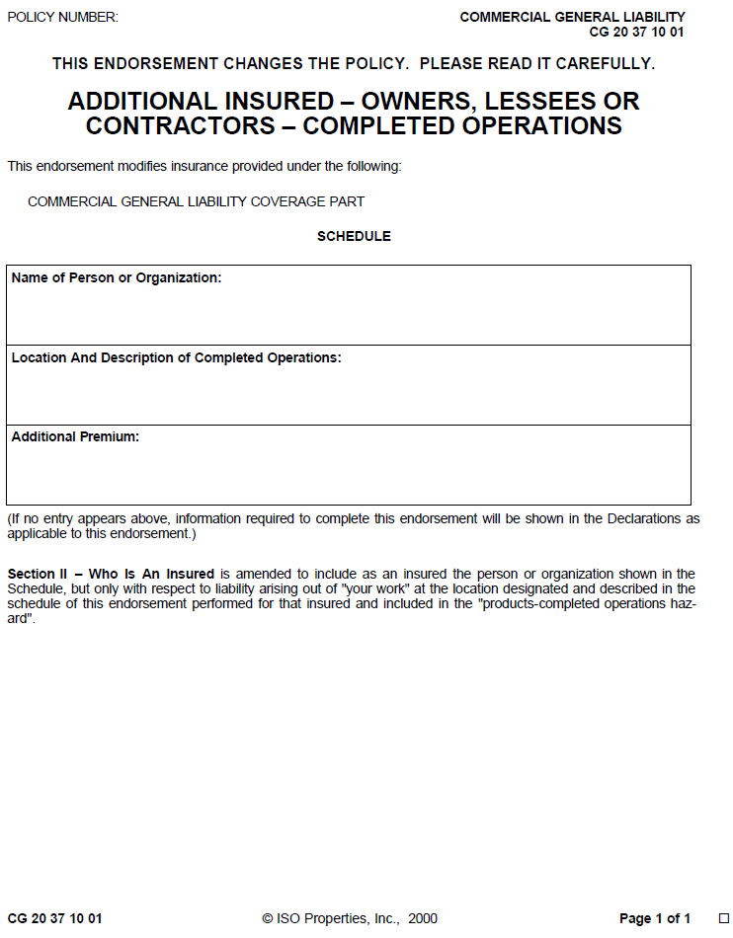
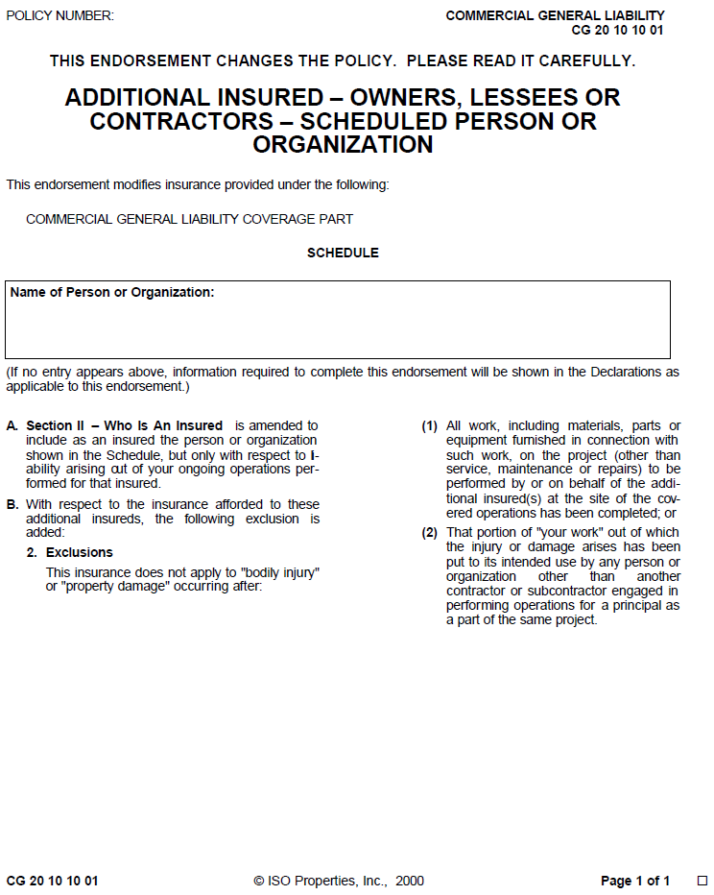
Insurance Requirements
for DE Agreements Page 7 of 11
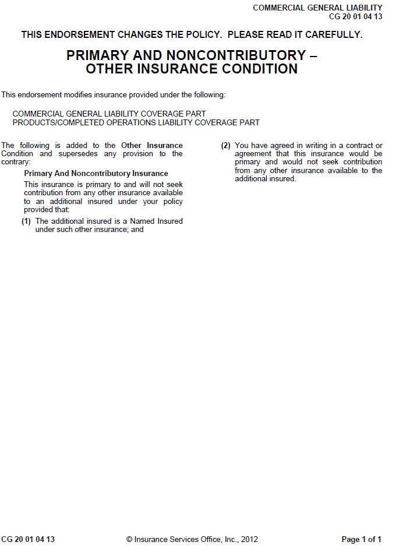
Insurance Requirements
for DE Agreements Page 8 of 11
Insurance Requirements
for DE Agreements Page 9 of 11
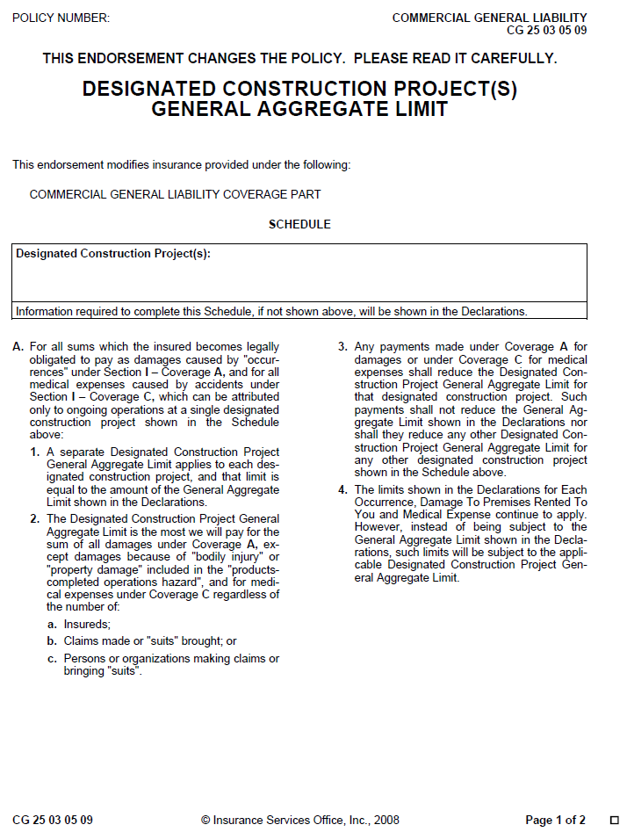
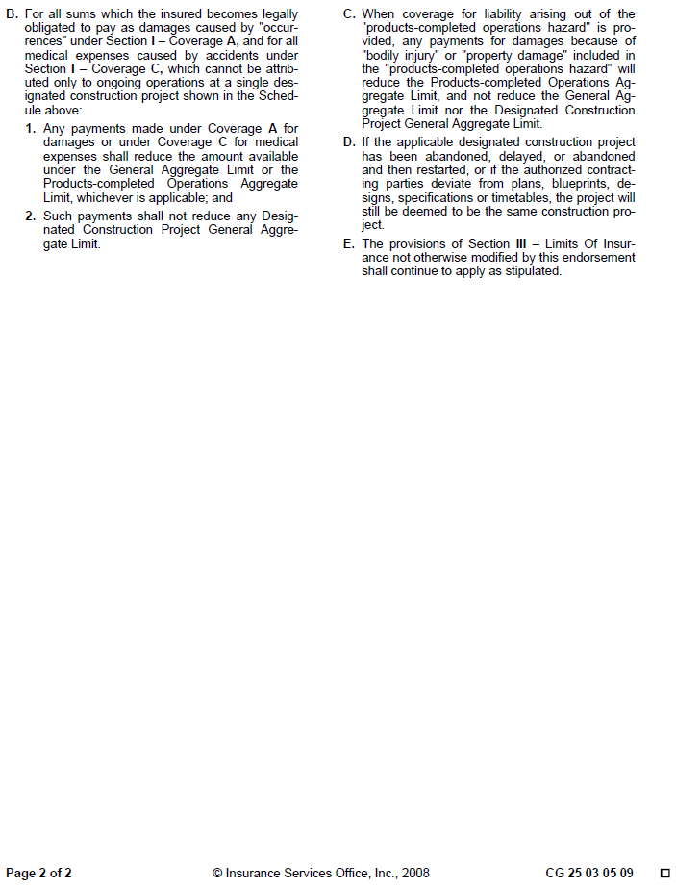
Insurance Requirements
for DE Agreements Page 10 of 11

Insurance Requirements
for DE Agreements Page 11 of 11

This page is intentionally left blank.

BILL OF SALE OF WATER FACILITIES
(Individual or Partnership)

The undersigned (“Grantor”) hereby conveys and transfers to King County Water District No. 20 ("District"), Burien, Washington, the property described on Attachment A:
See Attachment A attached hereto
This conveyance is made in consideration of the District accepting and incorporating the extension improvements into the overall water system of the District, and the District’s agreement to provide routine maintenance of said property and to provide water services pursuant to the District's regulations, which may be amended from time to time.
The Grantor, and Grantor’s successors and assigns, covenant and agree to and with the District, and its successors and assigns, that the Grantor is the owner of said property and has good right and authority to sell the same and that the Grantor will, and does, hereby warrant and agree to defend the sale of said property to the District, its successors and assigns, against all and every person or persons whomsoever lawfully claiming or to claim the same. The Grantor warrants and represents that all bills for labor and material relating to the construction of the extension improvements have been paid.
The Grantor further guarantees that the property is fit for purposes intended, i.e., as for use as a water distribution system including distribution and supply lines adequate for the service intended and has been constructed in accordance with the conditions and standards of the District.
The Grantor covenants and agrees with the District to replace, repair and correct any defect in work or materials in respect to the personal property subject to this Bill of Sale arising during a period of two (2) year from date hereof, without cost to the District.
Dated this ____ day of _____________, 20___.
GRANTOR

By:

By:

By:

By:

Bill of Sale – Water Facilities
(Individual or Partnership) Page 1 of 3
STATE OF WASHINGTON | )
 | ) ss
COUNTY OF KING | )

I certify that I know or have satisfactory evidence that ________________________________
____________________________________________________ is/are the person(s) who appeared before me, and said person(s) acknowledged that he/she signed this instrument and acknowledged it to be his/her free and voluntary act for the uses and purposes mentioned in the instrument.

DATED:

NAME:
(Print Name)
Notary Public in and for the State of Washington
Commission Expires:

Bill of Sale – Water Facilities
(Individual or Partnership) Page 2 of 3

Bill of Sale – Water Facilities
(Individual or Partnership Page 3 of 3
BILL OF SALE – WATER FACILITIES
ATTACHMENT A

DESCRIPTION OF SYSTEM FOR DEVELOPER EXTENSION AGREEMENT PROJECT: ____________________________

IN | FROM | TO | SIZE | LENGTH

This page is intentionally left blank.

BILL OF SALE OF WATER FACILITIES
(Corporation or LLC Entity)

The undersigned (“Grantor”) hereby conveys and transfers to King County Water District No. 20 ("District"), Burien, Washington, the property described on Attachment A:
See Attachment A attached hereto
This conveyance is made in consideration of the District accepting and incorporating the extension improvements into the overall water system of the District, and the District’s agreement to provide routine maintenance of said property and to provide water services pursuant to the District's regulations, which may be amended from time to time.
The Grantor, and Grantor’s successors and assigns, covenant and agree to and with the District, and its successors and assigns, that the Grantor is the owner of said property and has good right and authority to sell the same and that the Grantor will, and does, hereby warrant and agree to defend the sale of said property to the District, its successors and assigns, against all and every person or persons whomsoever lawfully claiming or to claim the same. The Grantor warrants and represents that all bills for labor and material relating to the construction of the extension improvements have been paid.
The Grantor further guarantees that the property is fit for purposes intended, i.e., as for use as a water distribution system including distribution and supply lines adequate for the service intended and has been constructed in accordance with the conditions and standards of the District.
The Grantor covenants and agrees with the District to replace, repair and correct any defect in work or materials in respect to the personal property subject to this Bill of Sale arising during a period of two (2) year from date hereof, without cost to the District.
Dated this ____ day of _____________, 20___.
GRANTOR

By:

(Print or type name)
Its
(Title)
Bill of Sale – Water Facilities
(Corporationl or LLC Entity Page 1 of 3

STATE OF WASHINGTON | )
 | ) ss
COUNTY OF KING | )

I certify that I know or have satisfactory evidence that ____________ is the person who appeared before me, and said person acknowledged that he/she signed this instrument, and acknowledged it as the _____________ of ______________________ to be the free and voluntary act of such entity for the uses and purposes mentioned in the instrument.

DATED:

NAME:
(Print Name)
Notary Public in and for the State of Washington
Commission Expires:

Bill of Sale – Water Facilities
(Corporationl or LLC Entity Page 2 of 3

BILL OF SALE – WATER FACILITIES
ATTACHMENT A

DESCRIPTION OF SYSTEM FOR DEVELOPER EXTENSION AGREEMENT PROJECT: ____________________________

IN | FROM | TO | SIZE | LENGTH

Bill of Sale – Water Facilities
(Corporationl or LLC Entity Page 3 of 3

This page is intentionally left blank.

Recording Requested By And
When Recorded Mail To:

King County Water District No. 20
12606 First Avenue South
Burien, WA 98168

DOCUMENT TITLE: EASEMENT NO._____ FOR WATER LINES
GRANTOR(S): (NAME)
(ADDRESS)
(ADDRESS)
ADDITIONAL GRANTORS ON PAGE ___ OF DOCUMENT
GRANTEE: KING COUNTY WATER DISTRICT NO. 20
ABBREVIATED LEGAL DESCRIPTION:
[Full legal description is located on Ex. A, page _____.]
ASSESSOR’S TAX/PARCEL NUMBER(S):
REFERENCE NUMBER OF RELATED DOCUMENT:

EASEMENT FOR WATER LINES
The undersigned _____________________________ (“Grantor”), for and in consideration of good and valuable consideration, the receipt and adequacy of which are hereby acknowledged, hereby grants and conveys to KING COUNTY WATER DISTRICT NO. 20, a municipal corporation in King County, Washington (“Grantee”), and its successors and assigns, a permanent Easement for Water Lines and appurtenances thereto (“Easement”) as follows:

- Nature and Location of Easement. Grantor owns the real property legally described in Exhibit “A”, attached hereto and incorporated herein by this reference (the “Real Property”). The Easement granted by Grantor herein shall be a permanent easement for the benefit of Grantee over, upon, across, through and under a portion of the Real Property, such Easement being legally described on Exhibit “B” and depicted on Exhibit “C” attached hereto and incorporated herein by this reference, for the purposes of installing, laying, constructing, maintaining, inspecting, repairing, removing, replacing, renewing, using and operating water lines, together with all facilities, connectors and appurtenances (“Water Lines”), including the right of ingress and egress for said purposes.

- Access Easement. Grantor also hereby dedicates, conveys and grants to Grantee a permanent non-exclusive access easement for ingress and egress over the portion of the Real Property as legally described on Exhibit “B” attached hereto (“Access Easement”) and as depicted on Exhibit “C” attached hereto.
Easement for Water Lines Page 1 of 6

- Right of Entry. Grantee shall have the right, without notice and without prior institution of any suit or process at law or equity, at all times as may be necessary to enter upon that portion of the Real Property covered by the Easement and Access Easement to install, lay, construct, maintain, inspect, repair, remove, replace, renew, use and operate the Water Lines for the purposes of serving the Real Property and other properties with utility service. Grantee agrees to restore the Real Property as nearly as reasonably possible to its condition prior to any material disturbance from construction, operation, maintenance, repair, or replacement of the Water Lines.

- Encroachment/Construction Activity. Grantor shall not undertake, authorize, permit or consent to any construction or excavation including, without limitation, digging, tunneling, or other forms of construction activity on or near the Easement which might in any fashion unearth, undermine, or damage the Water Lines or endanger the lateral or other support of the Water Lines without Grantee’s prior written approval. Grantor further agrees that no structure or obstruction, including, without limitation, fences and rockeries shall be erected over, upon or within the Easement, and no trees, bushes or other shrubbery shall be planted or maintained within the Easement, provided Grantor shall have full use of the surface of the Real Property within the Easement, so long as such use does not interfere with this Easement for Water Lines.

- Binding Effect/Warranty of Title. The Easement and the covenants, terms, and conditions contained herein are intended to and shall run with the Real Property and shall be binding upon Grantor and Grantee and their respective successors, heirs and assigns. Grantor warrants that Grantor has good title to the Real Property and warrants the Grantee title to and quiet enjoyment of the Easement.

- Recording. Upon its execution, the Easement shall be recorded with the Department of Records and Elections, King County, Washington.

DATED this ____ day of _________________, 20____.
Easement for Water Lines Page 2 of 6

GRANTOR(S)
By |  | By
 | Signature |  | Signature
 | Printed or typed name |  | Printed or typed name
Its |  | Its
 | Print or type position held |  | Print or type position held
INDIVIDUAL ACKNOWLEGEMENT

STATE OF WASHINGTON | )
 | ) ss
COUNTY OF KING | )

I certify that I know or have satisfactory evidence that _________________________ is the person who appeared before me, and said person acknowledged that he/she signed this instrument and acknowledged it to be his/her free and voluntary act for the uses and purposes mentioned in the instrument.

DATED:

NAME:
(Print Name)
Notary Public in and for the State of Washington
Commission Expires:

ENTITY ACKNOWLEDGEMENT

STATE OF WASHINGTON | )
 | ) ss
COUNTY OF KING | )

I certify that I know or have satisfactory evidence that ______________________ is the person who appeared before me, and said person acknowledged that he/she signed this instrument, and acknowledged it as the _________________________ of ___________________ to be the free and voluntary act of such entity for the uses and purposes mentioned in the instrument.

DATED:

NAME:
(Print Name)
Notary Public in and for the State of Washington
Easement for Water Lines Page 3 of 6
Commission Expires:

Easement No. _________________

EXHIBIT “A”

LEGAL DESCRIPTION OF PROPERTY

Easement for Water Lines Page 4 of 6

Easement No. _________________

EXHIBIT “B”

LEGAL DESCRIPTION OF EASEMENT

Water Easement

A fifteen (15’) foot strip of land lying seven and one half (7.5’) feet on each side of the centerline of the water main and appurtanences as constructed on the subject parcel; said centerline being described as follows:

[Insert centerline legal description here]

Easement No. _________________
Easement for Water Lines Page 5 of 6

EXHIBIT “C”

DEPICTION OF EASEMENT

Easement for Water Lines Page 6 of 6

King County Water District No. 20
12606 First Avenue South
Burien, Washington 98168

REAL PROPERTY LICENSE
The undersigned, _____________________________________, hereinafter "Licensor" whose address is _______________________________________________, is the owner of certain real property described in Exhibit "A", attached hereto and by this reference incorporated herein.

In order that Water District No. 20, King County, Washington, hereinafter "Licensee", may inspect, repair and maintain the bypass meter located on the above-described property, the benefit of which to Licensor is hereby acknowledged, Licensor does hereby grant and convey to Licensee and its contractors or agents a license to enter the property and the detector check vault located thereon at such time as Licensee deems necessary to read, inspect, repair and/or maintain the bypass meter. The Licensor shall provide Licensee with a key to allow access to the fire riser rooms where the detector check valve and by pass meters are located.

This license may not be revoked without the written consent of Licensee. Licensor shall not attempt to revoke the same without Licensee's written consent. Licensee’s consent to revoke the license shall not be unreasonably withheld where the access rights granted herein are no longer necessary. In the event Licensor fails to comply with the terms of this license or the Licensee’s policies and procedures, the Licensee shall be entitled to terminate service to the property through the detector check valve assembly. The appropriate fire authority shall be immediately notified of any such termination of service.

This license, which is non-exclusive to Licensee, shall run with the property and constitute an encumbrance and servitude on the same and shall inure to the benefit of Licensee's successors in interest.

DATED this ___________ day of _____________________, 20______.

By

Its

Real Property License Page 1 of 2
INDIVIDUAL ACKNOWLEDGEMENT

STATE OF WASHINGTON | )
 | ) ss
COUNTY OF KING | )

I certify that I know or have satisfactory evidence that ___________________ is the person who appeared before me, and said person acknowledged that he/she signed this instrument and acknowledged it to be his/her free and voluntary act for the uses and purposes mentioned in the instrument.

DATED:

NAME:
(Print Name)
Notary Public in and for the State of Washington
Commission Expires:

ENTITY ACKNOWLEDGMENT

STATE OF WASHINGTON | )
 | ) ss
COUNTY OF KING | )

I certify that I know or have satisfactory evidence that ______________________ is the person who appeared before me, and said person acknowledged that he/she signed this instrument, and acknowledged it as the __________________________ of __________________________ to be the free and voluntary act of such entity for the uses and purposes mentioned in the instrument.

DATED:

NAME:
(Print Name)
Notary Public in and for the State of Washington
Commission Expires:
Real Property License Page 2 of 2
King County Water District No. 20

APPLICATION FOR REIMBURSEMENT AGREEMENT
FOR WATER FACILITIES

The undersigned ____________________________________ (“Applicant”) hereby applies to King County Water District No. 20 for a Reimbursement Agreement pursuant to Chapter 57.22 RCW and applicable District resolutions, policies and procedures, and pursuant to the Developer Extension Agreement executed by Applicant and District on ________________, 20__ (“Extension Agreement”).

THIS AGREEMENT MUST BE SUBMITTED TO THE DISTRICT PRIOR TO SUBMITTAL OF THE BILL OF SALE FOR THE EXTENSION FACILITIES AND PRIOR TO DISTRICT’S FINAL ACCEPTANCE OF THE EXTENSION FACILITIES CONSTRUCTED PURSUANT TO THE ABOVE-REFERENCED AGREEMENT.

Name of Applicant: ______________________________________
Name of Project: ______________________________________
Description of Project or Project portion for which reimbursement is requested:

APPLICANT:
Dated: __________________

Name:

Address:

Telephone:

Email:

This page is intentionally left blank.

King County Water District No. 20

REIMBURSEMENT AGREEMENT
THIS AGREEMENT is made and entered into this ____ day of _________, 20___, between King County Water District No. 20, a municipal corporation (“District”) and _________________________ (“Owner”) (individually a “Party” and collectively the “Parties”).

RECITALS

A. District is a duly organized water district under the laws of the State of Washington, and is empowered to furnish water service, among other things, to property owners within and without the District in the manner provided by law; and

B. Owner previously entered into a Developer Extension Agreement dated the _____ day of ___________, 20___, (“Extension Agreement”) for the construction and installation of certain water facilities ("Extension Facilities") to serve Owner’s property which is legally described in Exhibit "A" attached hereto (“Developed Area”). The Extension Facilities are described in Exhibit “B” attached hereto. Owner completed installation of the Extension Facilities in accordance with the terms of the Extension Agreement, portions of which make utility service available to real property other than the Developed Area hereinafter referred to as the benefited properties ("Benefited Properties") as described in Exhibit "C" attached hereto. The owners of such Benefited Properties have not contributed to the cost of the Extension Facilities and Owner is entitled to reimbursement from real property owners seeking connection to or use of the Extension Facilities for the cost of the Extension Facilities in excess of Owner’s pro rata share therefor which costs have been determined as set forth below; and

C. District will collect charges from the owners of the Benefited Properties connecting to or using the Extension Facilities; and such charges are the sole source of funds for the District from which reimbursement to Owner can and will be made, as and when the same are collected; and

D. District is authorized to enter into a reimbursement agreement with Owner under the provisions of Chapter 57.22 RCW; and the Parties desire to enter into a written reimbursement agreement with reference to the foregoing matter, now, therefore,

AGREEMENT
Reimbursement Agreement Page 1 of 9

IN CONSIDERATION of the following terms and conditions, the District and the Owners agree as follows:

1. Completion of Extension Facilities. The installation of the Extension Facilities described on Exhibit “B” in the Developed Area has been completed by Owner under an Extension Agreement with District; and title thereto has been transferred to District, and such Extension Facilities are a part of the District water system.

2. Records/Costs. Owner has obtained and submitted to the District competitive bids as required by the District Engineer for the Extension Facilities qualifying for reimbursement and has kept accurate records which have been provided to the District of the actual costs of installing such Extension Facilities in accordance with the Extension Agreement. The District Engineer has reviewed and approved the costs of such Extension Facilities as reasonable and actual costs and District accepts such costs as costs which are subject to reimbursement; and District agrees to reimburse Owner in the manner and on the terms and conditions set forth in this Agreement. Owner agrees to reimburse the District for all costs and charges incurred by the District to prepare and set up the reimbursement contract referenced herein, including but not limited to, all legal, engineering and administrative costs and charges.

3. Method of Reimbursement.

A. Benefited Properties. The properties benefiting from the installation of the Extension Facilities which have not contributed to the original cost thereof are described in Exhibit “C” attached hereto.

B. Reimbursement Charges.

(1) Amount. District shall collect the pro rata share of the cost of construction and contract administration costs of the Extension Facilities as a charge from the owners of Benefited Properties desiring to connect to or use the Extension Facilities. The amount of the reimbursement charges to be collected prior to such connection is set forth in Exhibit “C”. Such charges may include, but are not limited to, the pro rata share of District legal, engineering, administrative, set-up, handling and actual costs of the Extension Facilities. Such reimbursement charges shall be in addition to all other District charges in effect as the time of seeking connection to such Extension Facilities. Upon application for connection by the owners of the Benefited Properties, the District may further segregate reimbursement charges attributed to the Benefited Properties. All costs of such segregation shall be borne by the party requesting such segregation.
(2) Payment. Upon payment to the District of a reimbursement charge as provided herein, District shall first deduct its administrative charge equal to ten percent (10%) of the reimbursement charge collected to cover its administrative costs. The remaining balance (90%) of the reimbursement charge collected shall be paid over to Owner within sixty (60) days after receipt thereof. The District shall follow its established procedures of depositing such funds received with the County Treasurer and drawing upon the same and effecting payment by County Treasurer Warrant in the manner provided by law.
Reimbursement Agreement Page 2 of 9

C. Charge: Satisfaction and Discharge. The amounts payable by the Benefited Properties desiring to connect to the Extension Facilities shall be recorded as a charge upon such real property until paid in full. When paid, the charge shall be satisfied and discharged of record. Owner hereby appoints the Secretary of the District Board of Commissioners, or his/her successor, as its attorney-in-fact, to prepare, execute and file for record with King County a document appropriate to reflect the payment and satisfaction of the charge and release of the obligation of the applicable Benefited Properties to pay the reimbursement charge to the District. The document filed by District shall describe the applicable Benefited Properties connecting to the Extension Facilities and paying the reimbursement amount, and thereupon this Agreement shall no longer apply to such real property. This appointment as attorney-in-fact is irrevocable during the term of this Agreement.

D. Payment Procedure. The District shall forward reimbursement funds referenced herein to Owner at Owner’s address provided herein or to Owner’s agent as authorized by Owner to the District in writing. As a condition of receiving such reimbursement funds, the District may require Owner or Owner’s agent to execute a receipt to the District for such reimbursement amounts so paid using a receipt form provided by the District.

In the event of a dispute as to the rightful party to receive such funds, District may pay the same to the Owner referenced herein or interplead such funds to the court. In either event, District shall thereupon be relieved of any further obligation or of any liability hereunder as to such reimbursement funds so paid.

4. Owner Contact Information. The Owner shall provide the District with contact information (“Contact Location”). The Owner’s initial Contact Location shall be as follows:
Reimbursement Agreement Page 3 of 9
Contact Information and Address for Receipt of Reimbursement Funds
(Printed Name of Owner’s Representative)
(Company Name)
(Mailing Address)
(City, State, Zip code)
(Telephone and Email)

The Owner shall inform the District, in writing, of its current Contact Location every two years from the Effective Date (“Contact Update Dates”), or sooner of Owner’s company name, address, and telephone number and email address for the receipt of reimbursement funds. If the Owner fails to submit its current Contact Location to the District within sixty (60) days of the Contact Update Dates, the District may terminate the right of the Owner to receive any reimbursement charges collected by the District after such Contact Update Date as described in Section 5 of this Agreement.

The notification of current Owner Contact Location shall be sent to the District at the following address, unless the District provides written notification to Owner of a change in the District’s address:

District Contact Information

General Manager
Water District No. 20
12606 First Avenue South
Burien, WA 98168

(206) 243-3990

5. Termination of Owner’s Right to Receive Reimbursement. In the event the District collects reimbursement charges from owners of Benefited Properties and the Owner has failed to comply with the notice requirements of Section 4 of this Agreement, the District will attempt to contact the Owner by mail at its most recent Contact Location and request the Owner to provide, within sixty (60) days from the date of mailing of the request, written confirmation of Owner’s Updated Contact Location. If the Owner fails to submit an Updated Contact Location within the 60-day period, the right of the Owner to receive reimbursement charges collected by the District shall terminate, and any reimbursement charges collected by the District following the 60-day period shall be collected and retained by the District and deposited in the District’s capital fund for expenditure by the District.

6. District Authority: Effective Date. District is authorized to enter into this Agreement in accordance with the provisions of Chapter 57.22 RCW. This Agreement shall remain in full force and effect for a period of seven (7) years from the date of the District’s acceptance of title to the Extension Facilities referenced herein from Owner, which date shall be the Effective Date of this Agreement. Owner shall have no further claim to any monies collected by District from any Benefited Properties after the expiration of the seven (7) year term.

7. Recording. This Agreement shall be recorded in the real property records of King County, Washington upon execution by the District and the Owner. This Agreement shall constitute a charge and obligation upon the Benefited Properties described in Exhibit “C” not contributing to the original cost of the Extension Facilities under the provisions hereof, and shall be binding upon the present owner thereof, and all successors in interest to those respective parties.
Reimbursement Agreement Page 4 of 9

8. Agreement Implementation and Indemnification. The District will use its best efforts to collect and distribute the reimbursement funds pursuant to the process set forth in this Agreement. However, the District, its officials, employee or agents shall not be held liable or responsible for failure to implement any of the provisions of this Agreement unless such failure was willful or intentional. Owner agrees to indemnify and hold the District harmless from any liability or damages of any nature or kind whatsoever arising out of claims and/or suits filed against the District as a result of any action taken pursuant to this Agreement, and shall defend the District whenever the District is named in a suit in which this Agreement is at issue and Owner shall pay all costs of such defense, including but not limited to attorney and expert witness fees and costs.

9. General. This Agreement constitutes the entire agreement between the Parties. All exhibits referred to herein are by this reference made a part of this Agreement as though set forth in full. This Agreement is binding upon the heirs, executors, administrators, successors and assigns, of each of the Parties hereto.

10. Assignment. The Owner shall not assign the whole or any part of this Agreement without the prior written consent of the District.

DISTRICT:

King County Water District No. 20

By
Its
OWNER:

By Its
Reimbursement Agreement Page 5 of 9
STATE OF WASHINGTON | )
 | ) ss
COUNTY OF KING | )

I certify that I know or have satisfactory evidence that __________________ is the person who appeared before me, and said person acknowledged that he/she signed this instrument, on oath stated that he/she was authorized to execute the instrument and acknowledged it as the ________________________ of King County Water District No. 20 to be the free and voluntary act of such municipal corporation for the uses and purposes mentioned in the instrument.

DATED: __________________________________

_________________________________________ (Print Name)

Notary Public in and for the State of Washington Residing at
My commission expires:

STATE OF WASHINGTON | )
 | ) ss
COUNTY OF KING | )

I certify that I know or have satisfactory evidence that ___________________ is the person who appeared before me, and said person acknowledged that he/she signed this instrument, on oath stated that he/she was authorized to execute the instrument and acknowledged it as the ___ of ___ to be the free and voluntary act of such entity for the uses and purposes mentioned in the instrument.

DATED: _____________________________

(Print Name)

Notary Public in and for the State of Washington Residing at
My commission expires:

EXHIBIT A
Reimbursement Agreement Page 6 of 9

LEGAL DESCRIPTION OF OWNER’S PROPERTY

EXHIBIT B
Reimbursement Agreement Page 7 of 9

DESCRIPTION OF EXTENSION FACILITIES

EXHIBIT C
Reimbursement Agreement Page 8 of 9

DESCRIPTION OF BENEFITED PROPERTIES
AND
IDENTIFICATION OF APPLICABLE REIMBURSEMENT CHARGES

Reimbursement Agreement Page 9 of 9

This page is intentionally left blank.

CERTIFICATION OF COST FORMS

KING COUNTY WATER DISTRICT NO. 20

DEVELOPER'S CERTIFICATE OF COST
WATER MAIN FACILITY
Certificate of Cost Page 1 of 2
Item No. |  | Description |  | Qty |  | Unit |  | Price |  | Amount
1. |  | Furnish and Install ______ – inch Water Main |  |  |  | LF
2. |  | Furnish and Install ______ – inch Water Main |  |  |  | LF
3. |  | Furnish and Install ______ – inch Water Main |  |  |  | LF
4. |  | Furnish and Install ______ – inch Water Main |  |  |  | LF
5. |  | Furnish and Install Pit Run Backfill |  |  |  | CY
6. |  | Furnish and Install ______ Inch Valves |  |  |  | Each
7. |  | Furnish and Install ______ Inch Valves |  |  |  | Each
8. |  | Furnish and Install ______ Inch Valves |  |  |  | Each
9. |  | Furnish and Place Concrete Blocking |  |  |  | CY
10. |  | Furnish and Install Water Main Fittings |  |  |  | Lbs
11. |  | Furnish and Install Fire Hydrants |  |  |  | Each
12. |  | Connect to Existing Mains |  |  |  | Each
13. |  | Sterilize, Flush and Test Mains |  |  |  | LS
14. |  | Furnish and Place Asphaltic Concrete Paving |  |  |  | SY
15. |  | Furnish and Place 3/4" Minus Crushed Rock |  |  |  | Ton
16. |  | Final Clean-up and Restoration |  |  |  | LS
 |  |  |  |  | Subtotal |  | $
 |  |  |  |  | Excise Tax |  | $
 |  |  |  |  | Total Cost |  | $
The undersigned hereby certifies that these costs truly represent the cost of installing water main facilities for the project known as:

Certifying Signature

*Use this form in conjunction with the reimbursement agreement.
Certificate of Cost Page 2 of 2

King County WATER DISTRICT NO. 20

DEVELOPER'S CERTIFICATE OF COST (SIMPLIFIED)
WATER MAIN FACILITY
Item No. | Description | Qty | Unit | Price |  | Amount
1. | Furnish and Install ______ – inch Water Main |  | LF
2. | Furnish and Install Fire Hydrants |  | Each
 |  | Subtotal |  |  | $
 |  | Excise Tax |  |  | $
 |  | Total Cost |  |  | $

The undersigned hereby certifies that these costs truly represent the cost of installing water main facilities for the project known as:
Certificate of Cost (Simplified) Page 1 of 2

Certifying Signature

Certificate of Cost (Simplified) Page 2 of 2

KING COUNTY WATER DISTRICT NO. 20

DEVELOPER'S CERTIFICATE OF COST (SIMPLIFIED)
SECONDARY WATER FACILITIES
Item No. | Description | Qty | Unit | Price |  | Amount
1. | Furnish and Install Fire Hydrants |  | Each
2. | Furnish and Install ____” Backflow Prevention Assembly |  | Each
3. | Furnish and Install ____” Backflow Prevention Assembly for Fire Sprinkler System |  | Each
4. | Furnish and Install ____” Backflow Prevention Assembly for Irrigation System |  | Each
5. | Sterilize, Flush and Test System |  | LS
6. | Furnish and Place 1 ¼” Crushed Rock |  | TON
7. | Furnish and Place Asphaltic Concrete Paving |  | SY
8. | Final Cleanup and Restoration |  | LS
 |  | Subtotal |  |  | $
 |  | Excise Tax |  |  | $
 |  | Total Cost |  |  | $

The undersigned hereby certifies that these costs truly represent the cost of installing water main facilities for the project known as:

Certifying Signature
Certificate of Cost Page 1 of 1
Secondary Water Facilities

This page is intentionally left blank.

